# Introduction of the System

* LIVESTOCK INSURANCE is a coverage for farmers which may cover cattle or other livestock in the event of illness or other accidents.
* They can protect themselves against the loss of valuable animals by purchasing this insurance. This insurance is typically used to cover domesticated animals such as cattle, sheep, pigs, and horses.
* An omnipresence solution to empower PRUDENT INSURANCE BROKER PVT. LIMITED (PIBL) sales agents by digitizing livestock insurance policy creation workflow, with livestock Insurance solutions*.*
* **Project Features**
* Generate Policy
* Search Policies, Drafts & Document Pendings
* Save As Draft
* Password Management
* User Registration
* Reports Generation
* NIA API Integration
* Feature Management
* Live Available Subsidies & Premium
* View All Drafts
* Generate Pending Policy Documents
* Online Payment Integration
* GPS Location And Marking.
* Restrict Upper Cash Limit
* E-Mail Notification & SMS Integration.
* SMS Sending
* User Excel List Upload
* Policy MIS Tool
* **User Types**
* Employee
* Non-PIBL
* Partners
* Customers/Members (Farmers)

# Snapshot of System

* Login Page

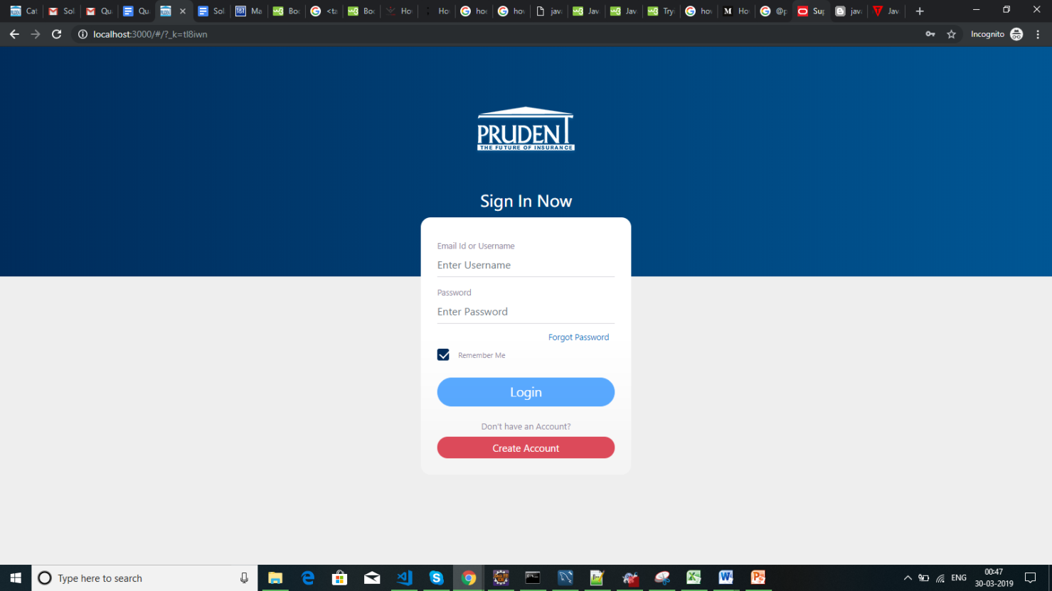

* DashBoard

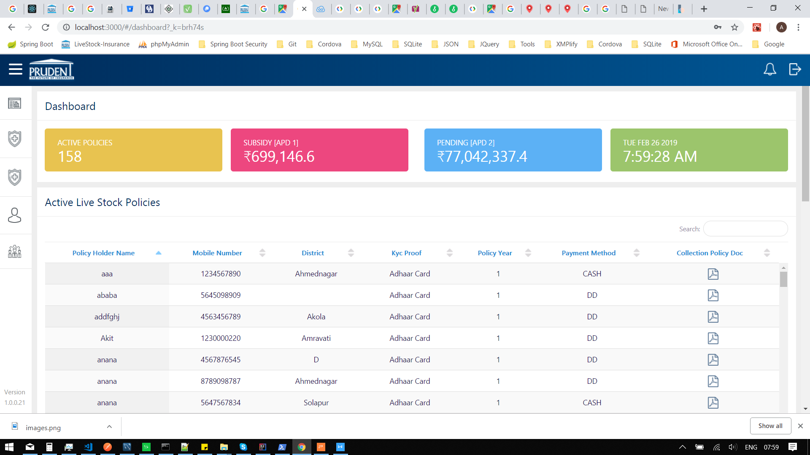

* Policy draft list

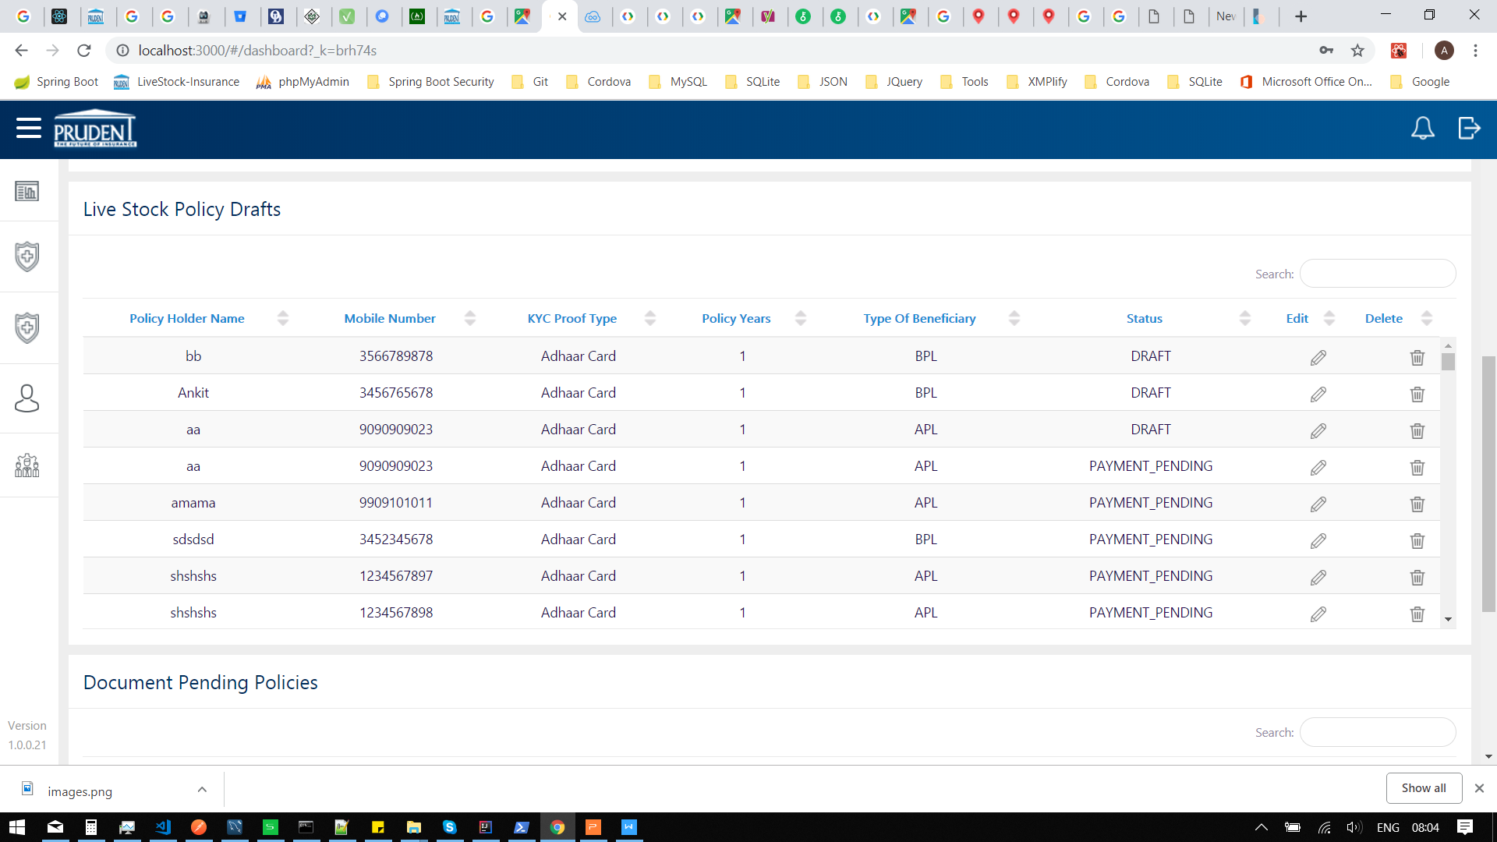

* Policy issued document pending list

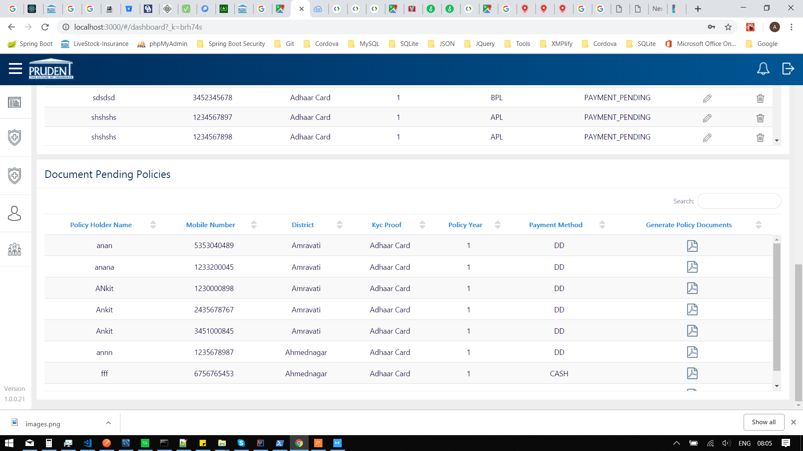

**POLICY CREATION STEPS**

* KYC Form

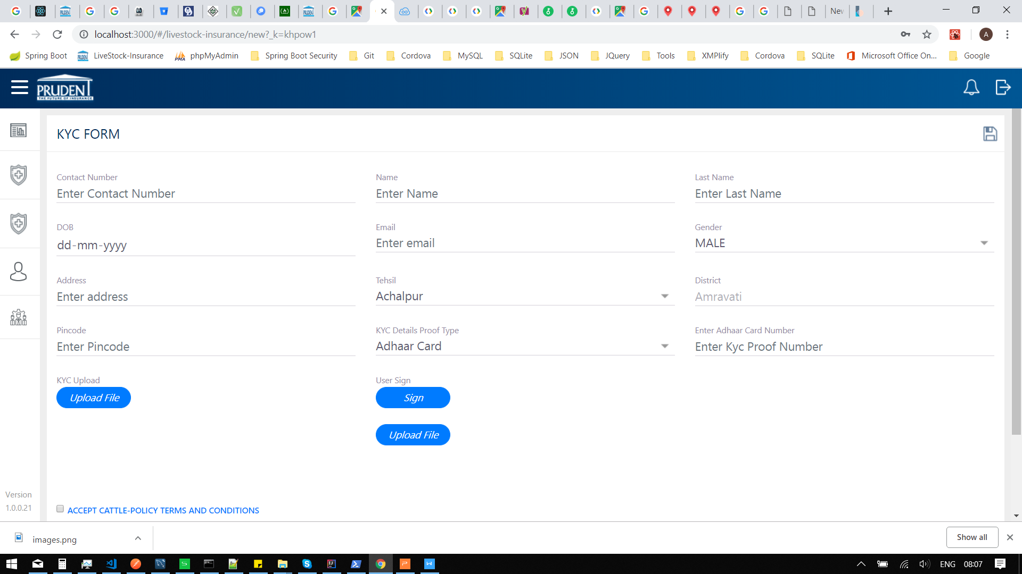

* KYC Form with data.

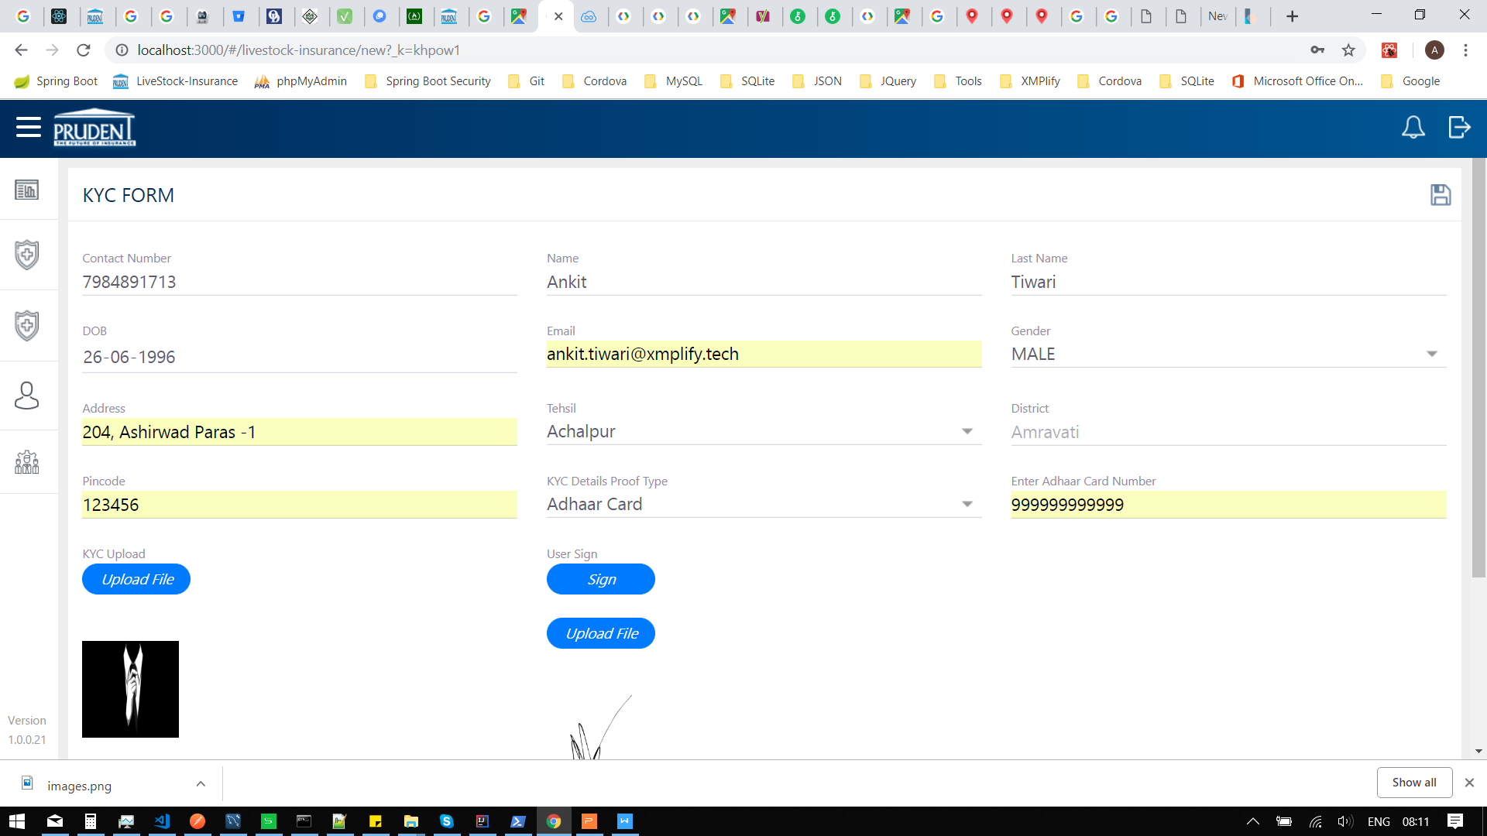

* KYC Form without data.

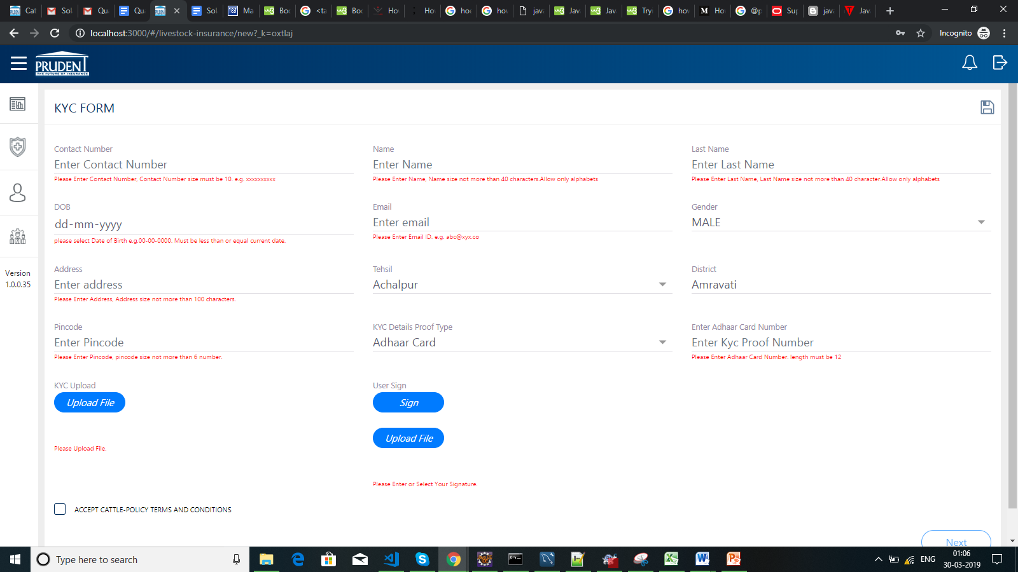

* Cattle Policy

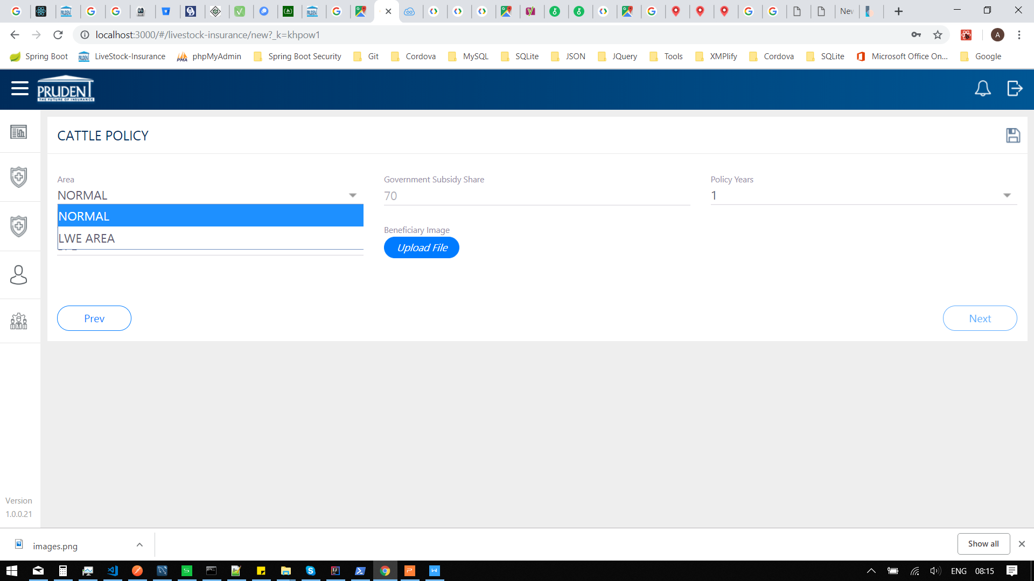

* Cattle Policy with data

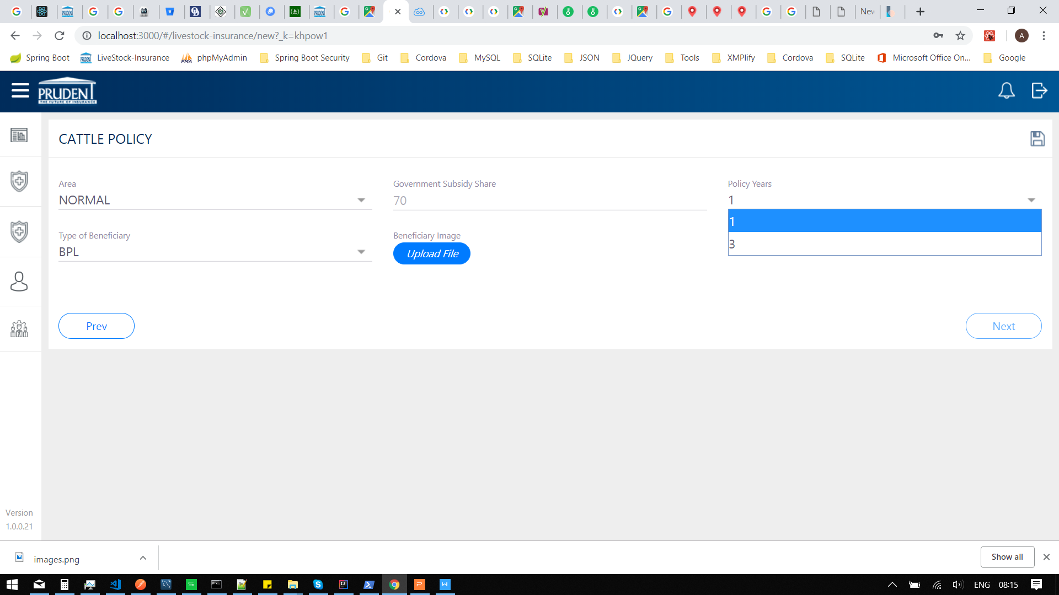

* Livestock Insurance

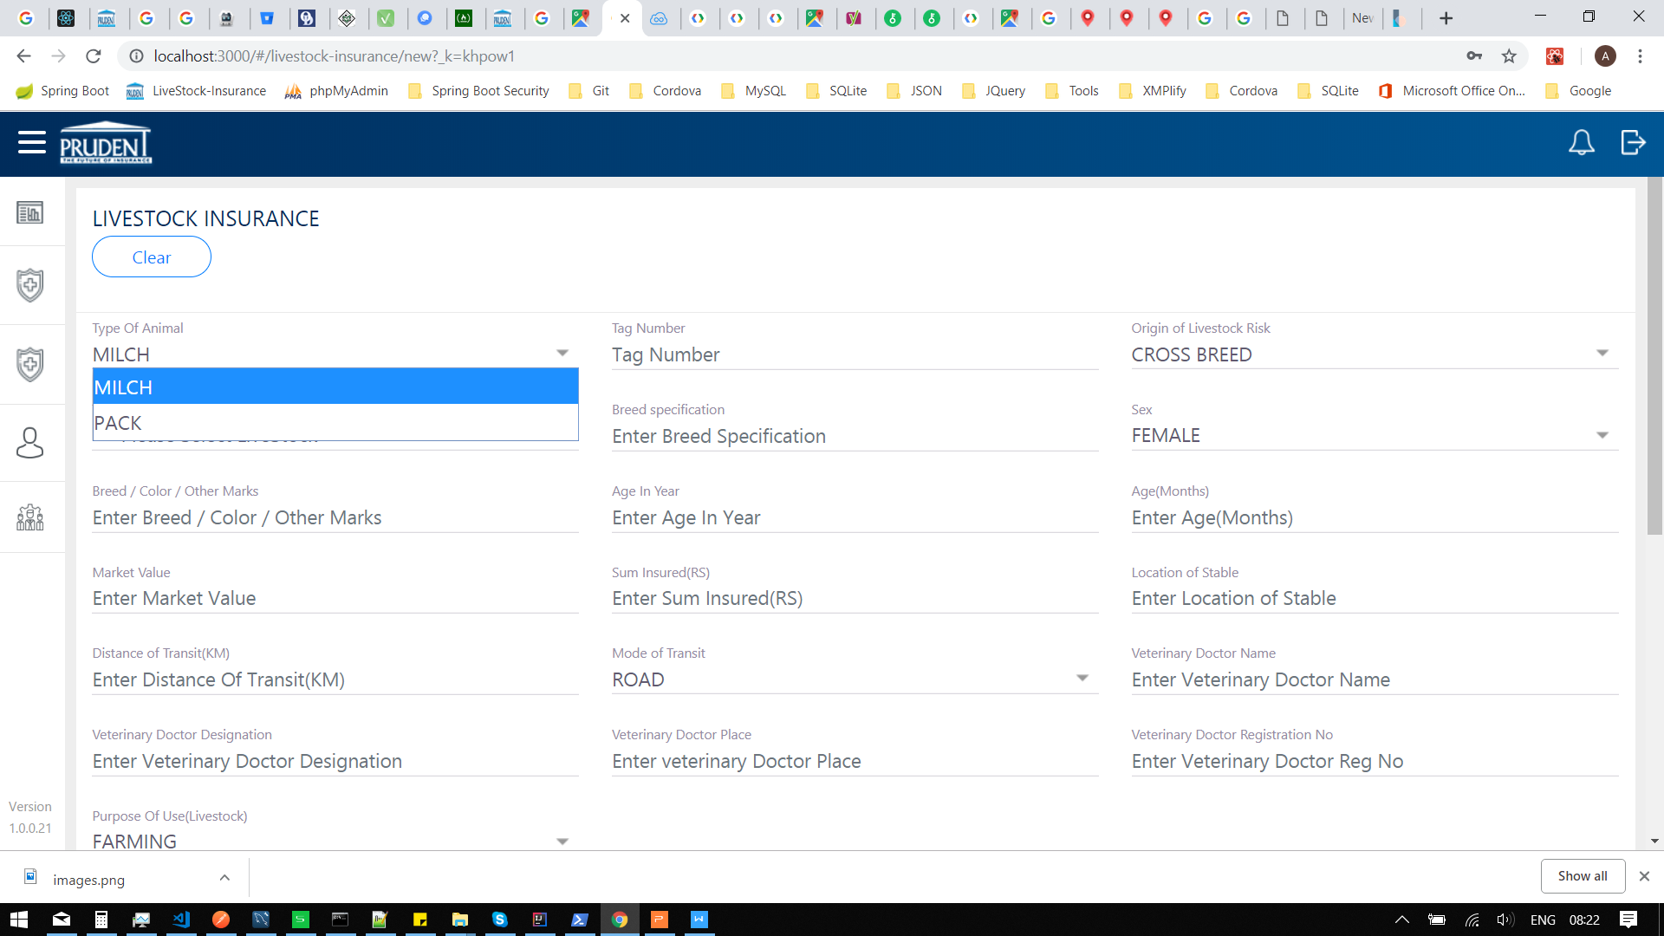

* LiveStock Insurance with data

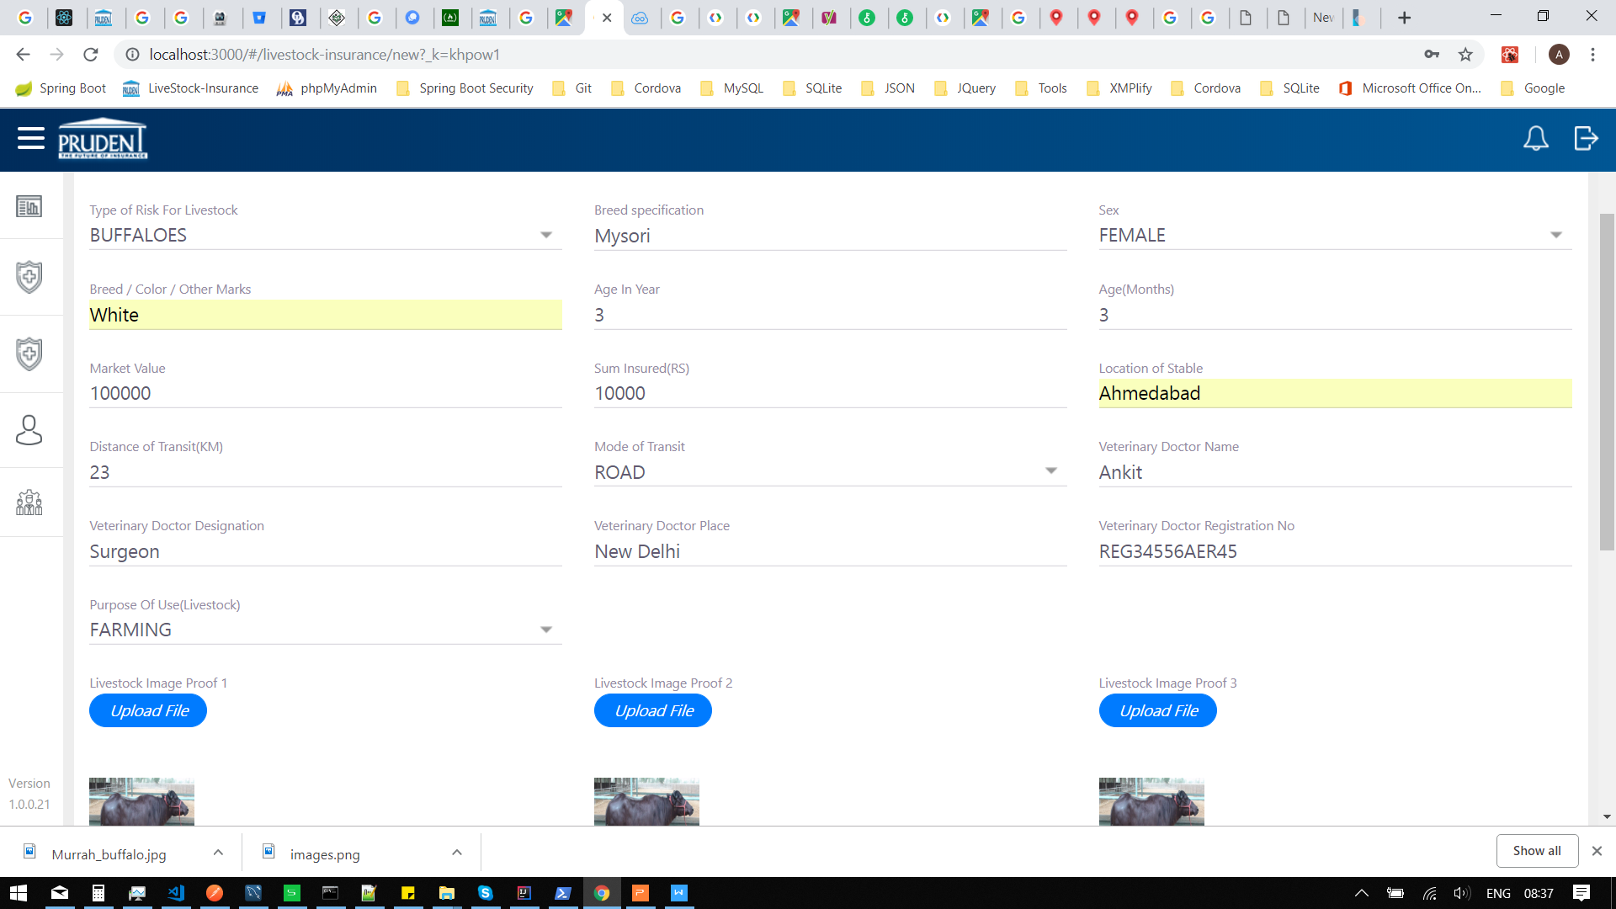

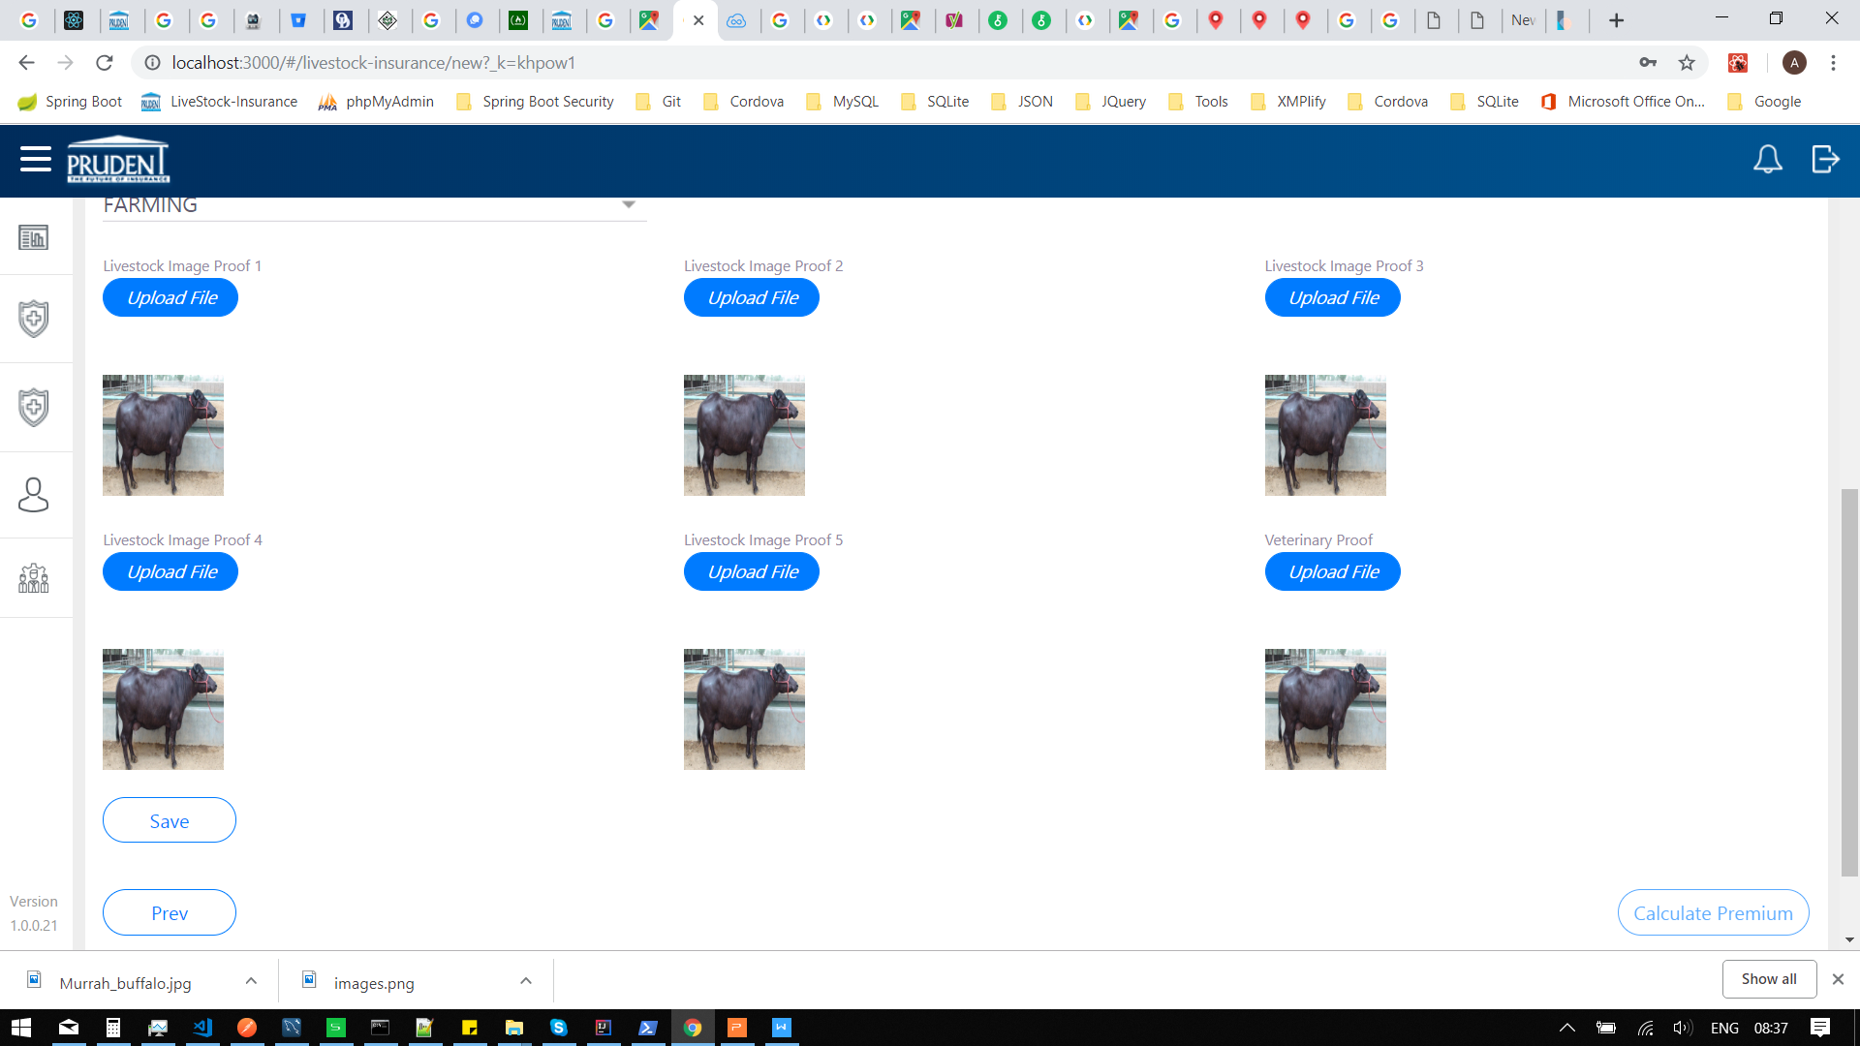

* LiveStock without data

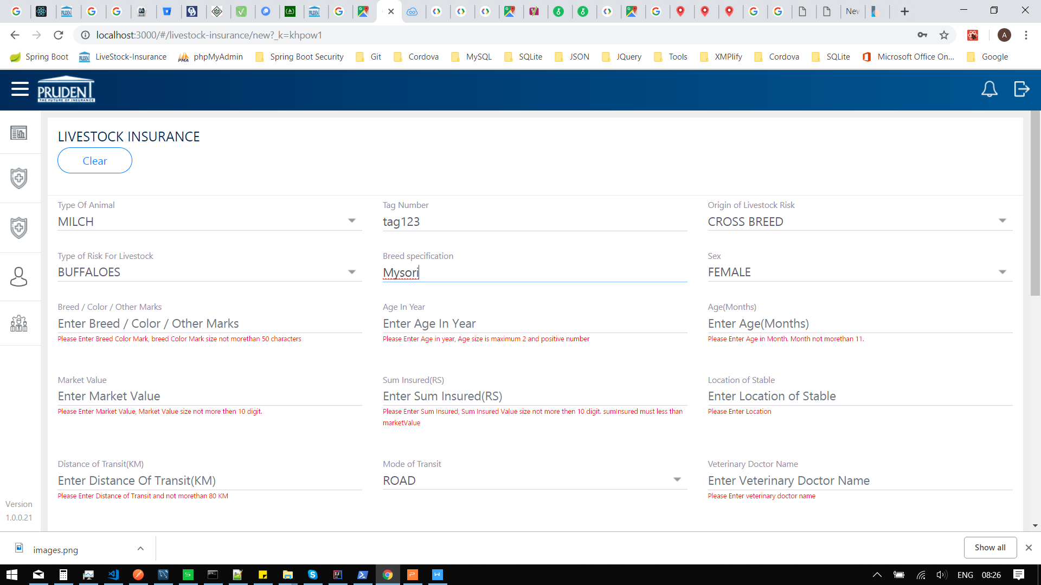

* Calculate Premium

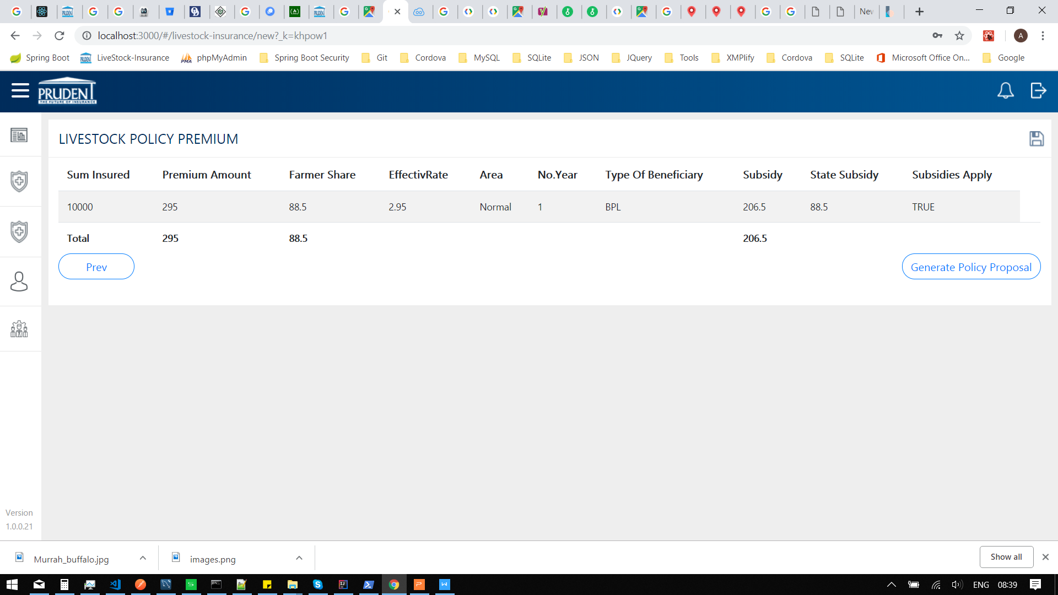

* Download Policy PDF

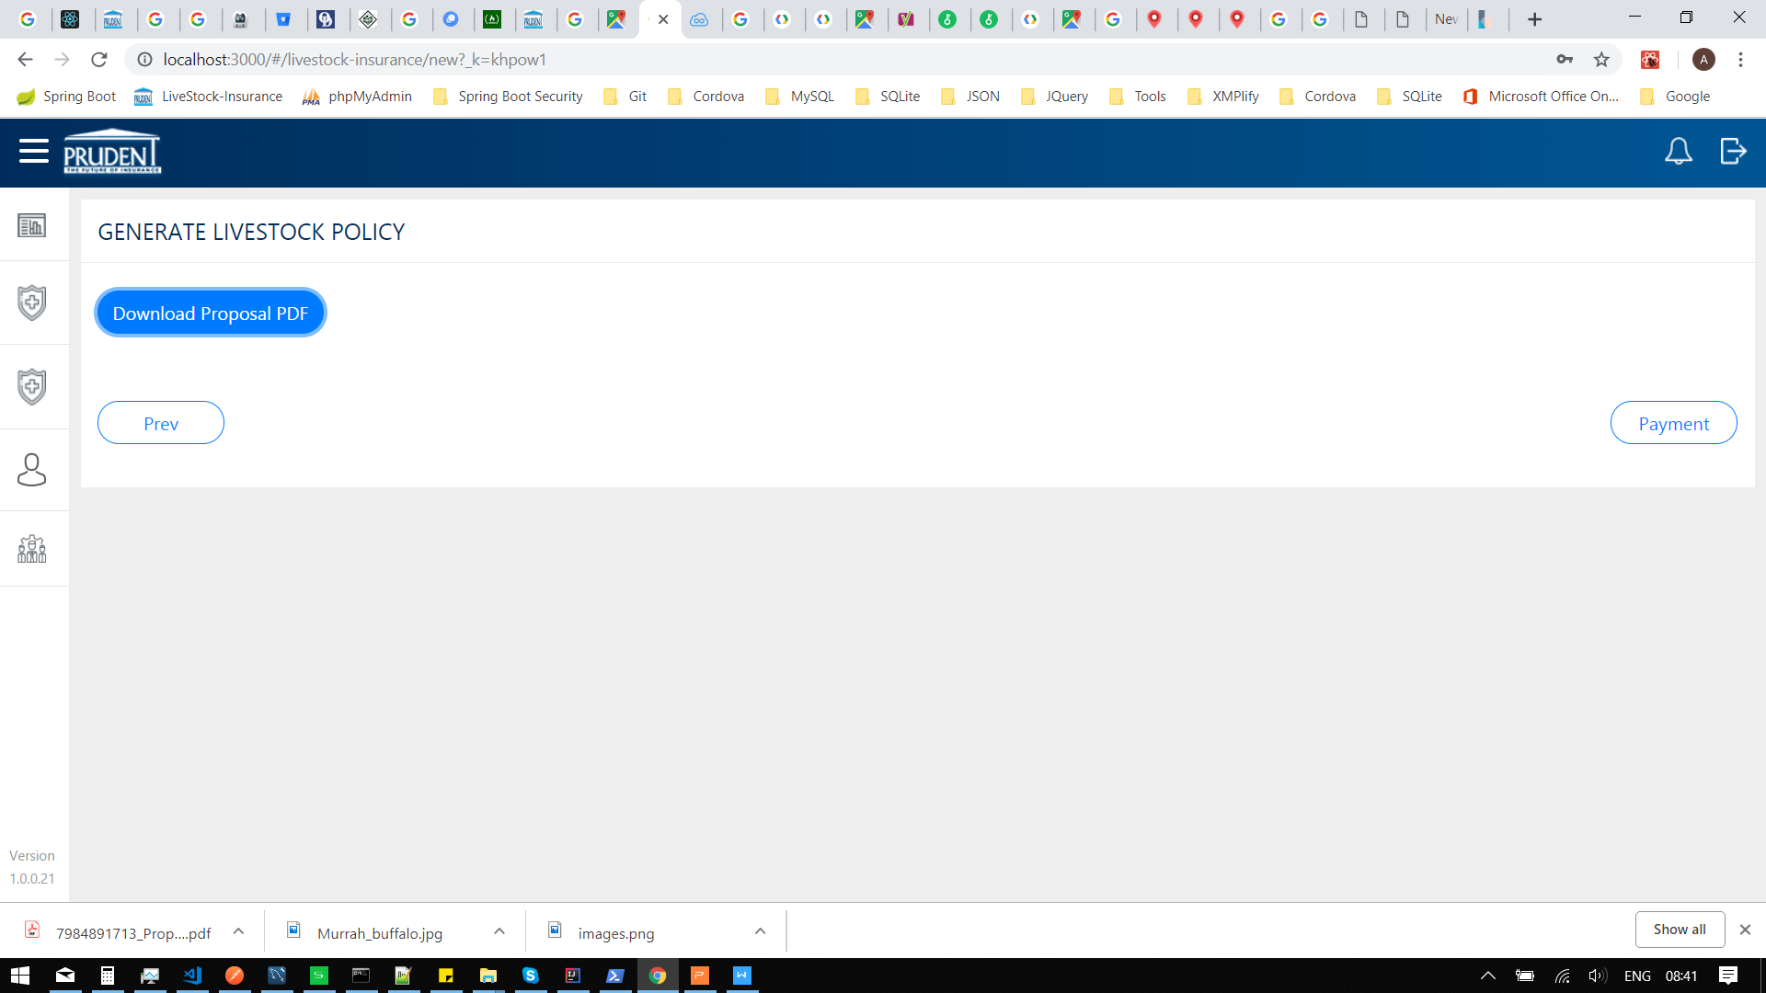

* Payment

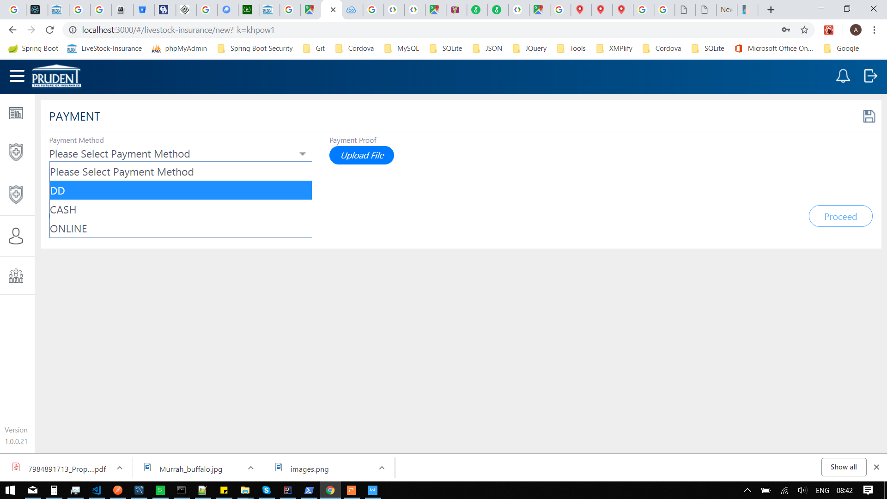

* Payment with data

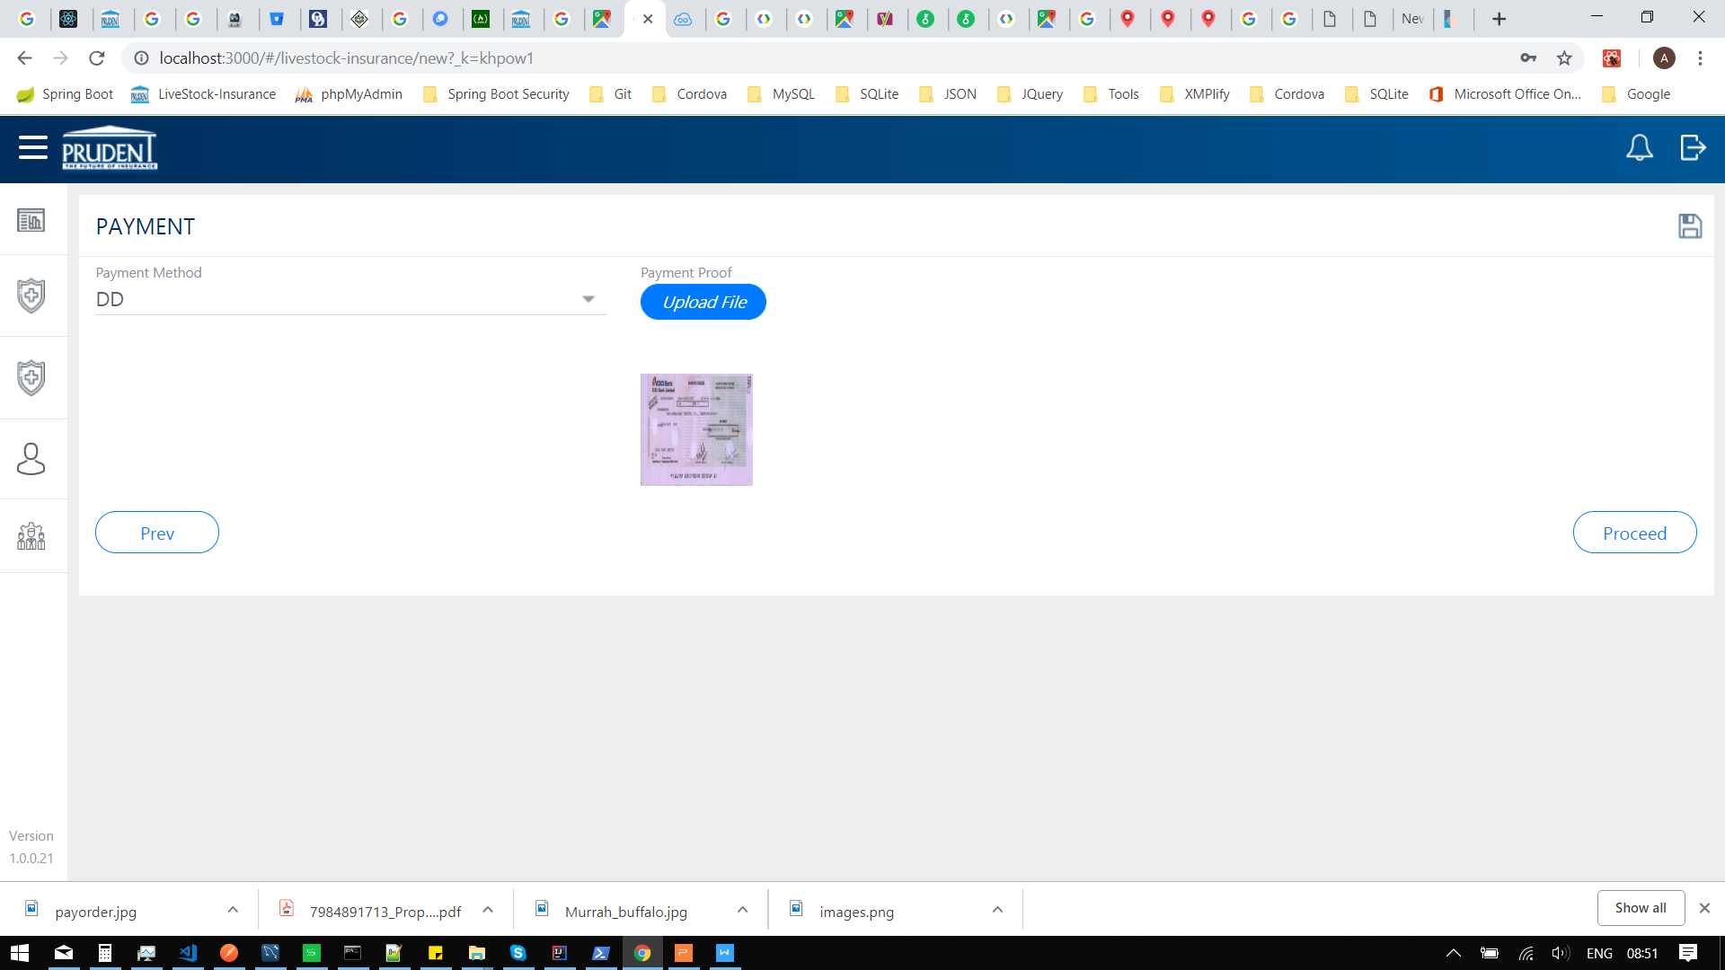

* NIA Policy PDF

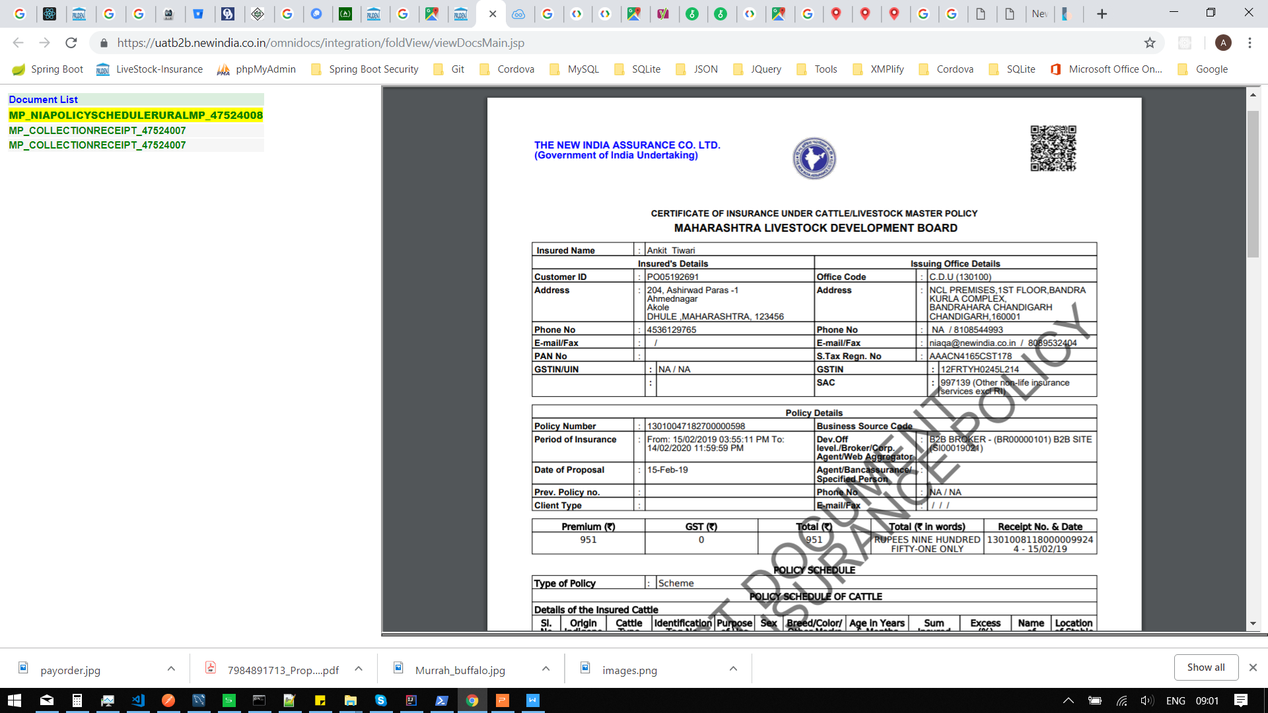

* Sidebar menu

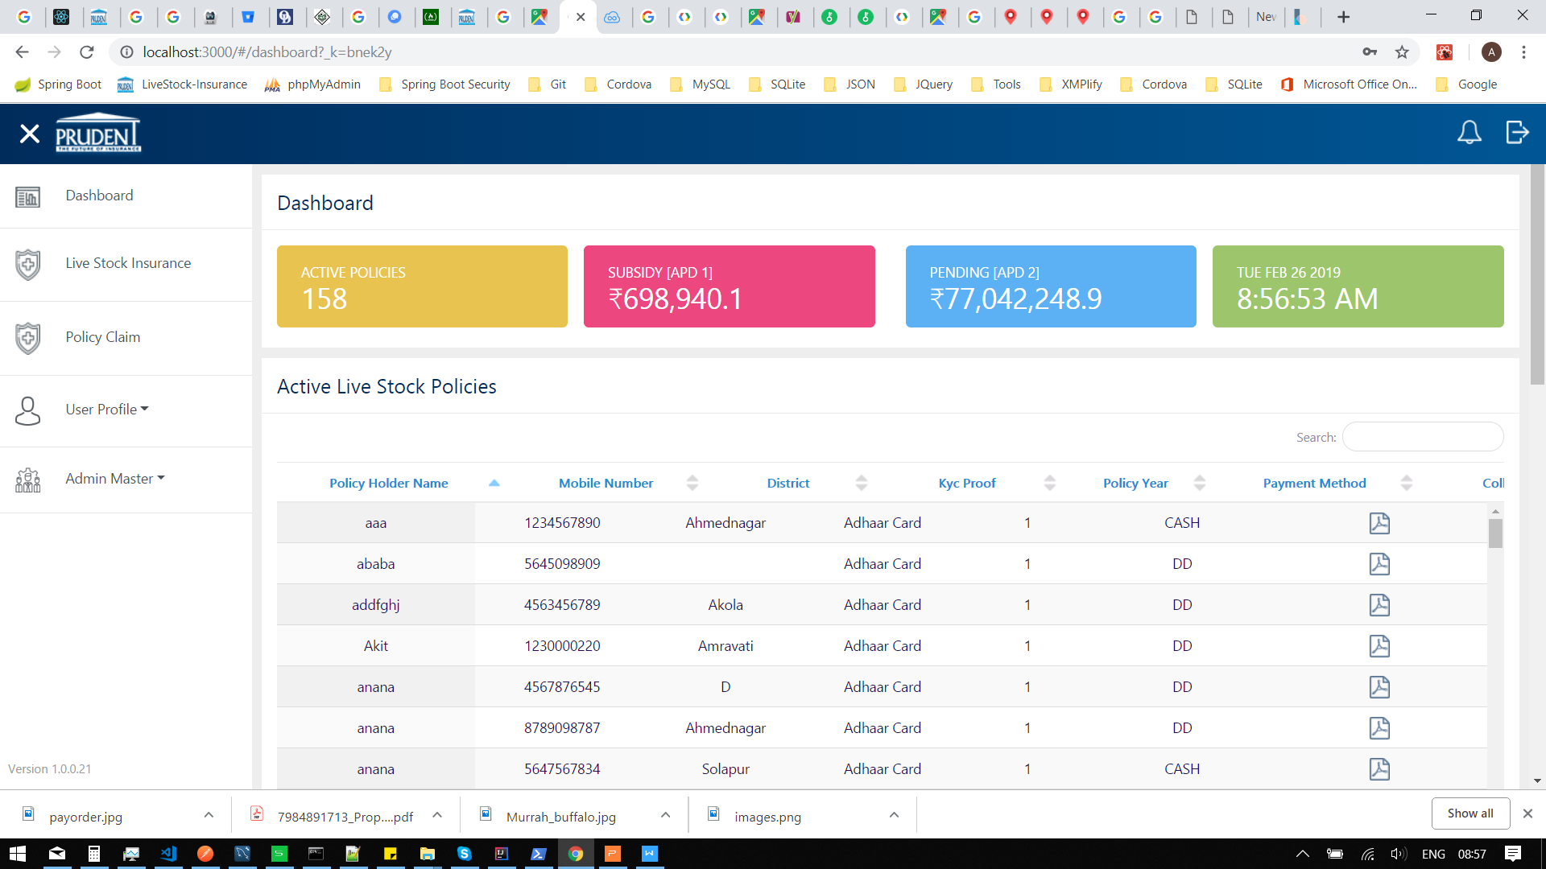

* User Profile

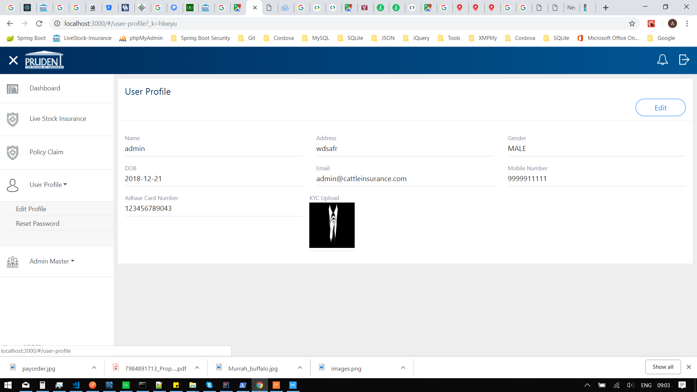

* User profile edit mode

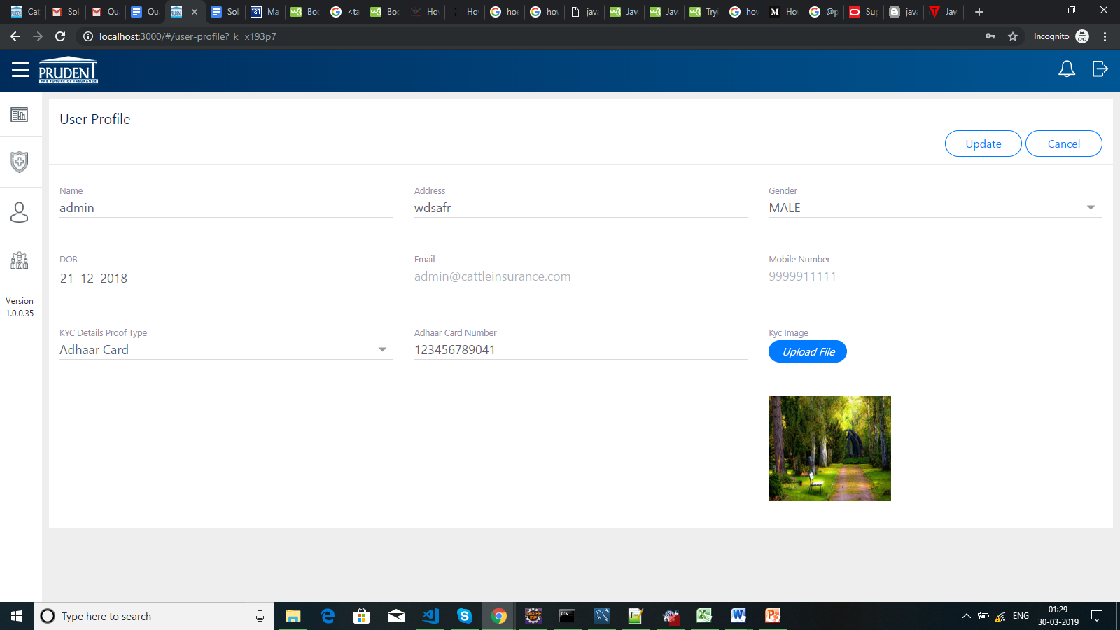

* User profile edit mode validation

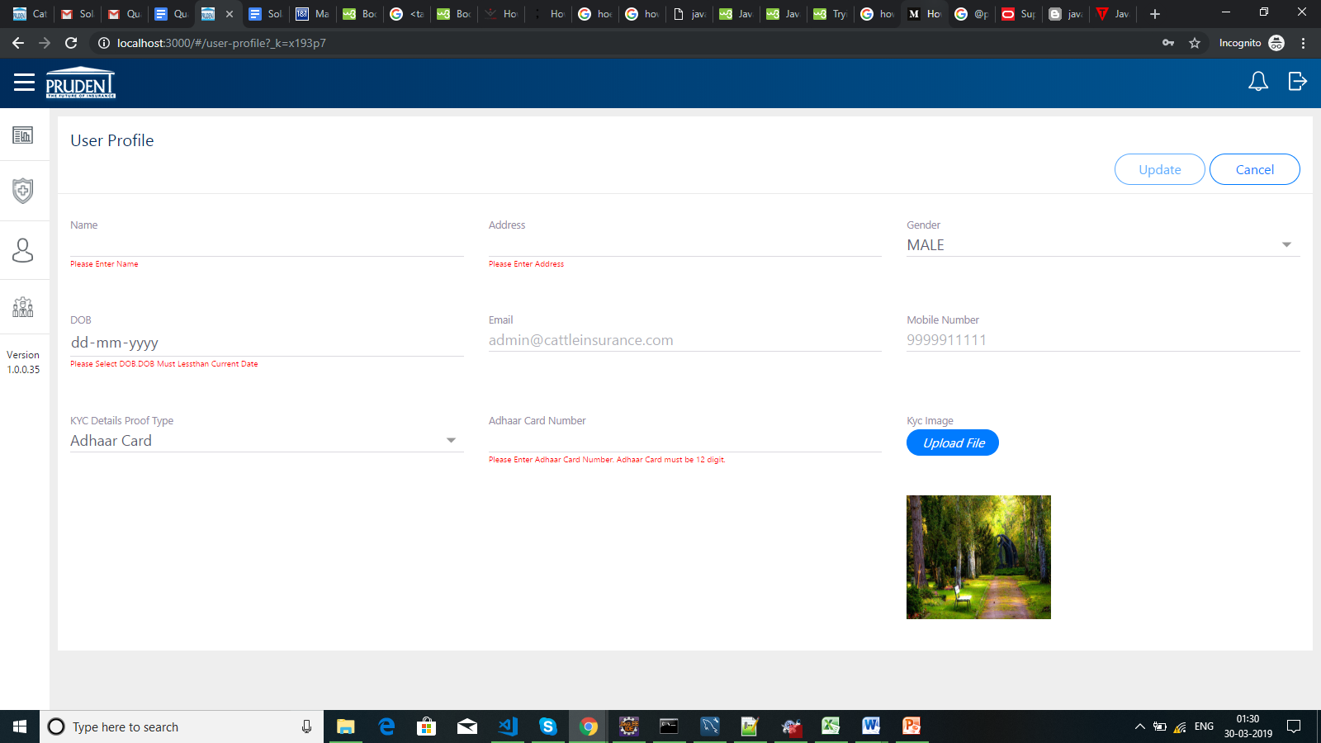

* Reset password

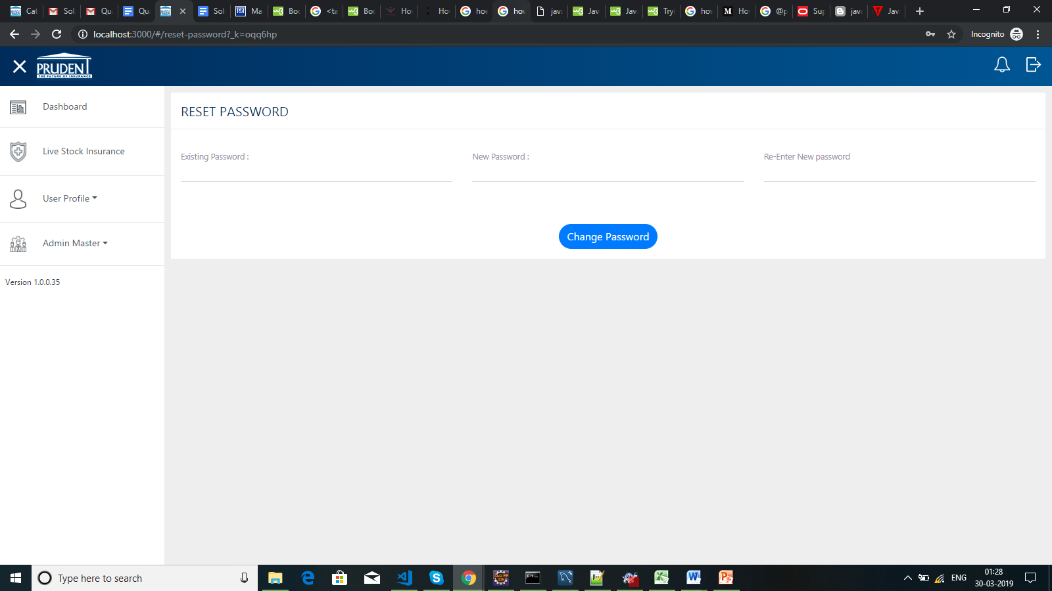

* Reset password validation

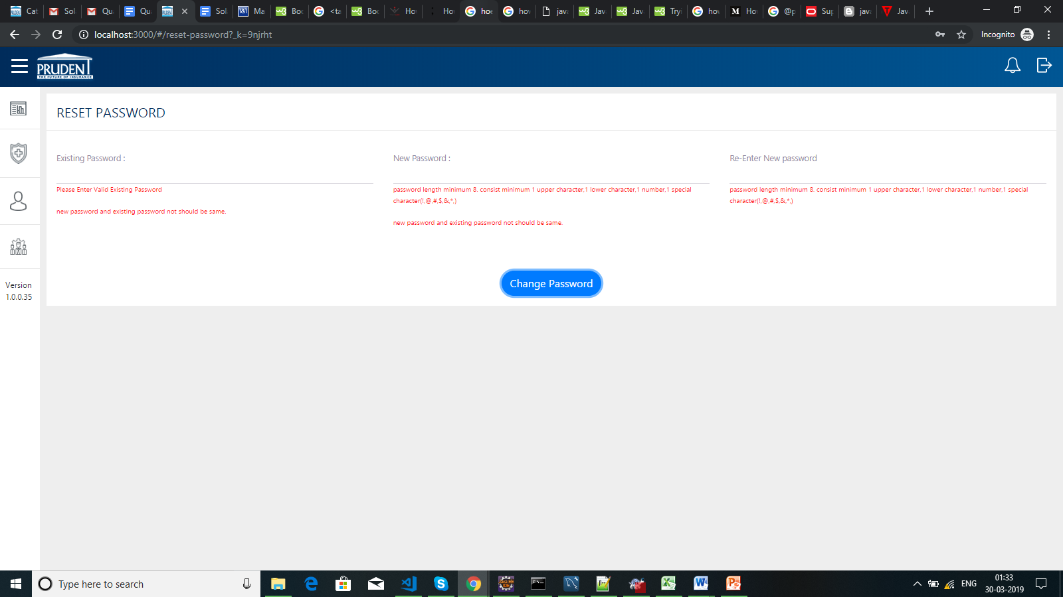

**ADMIN PANEL**

* User Registration

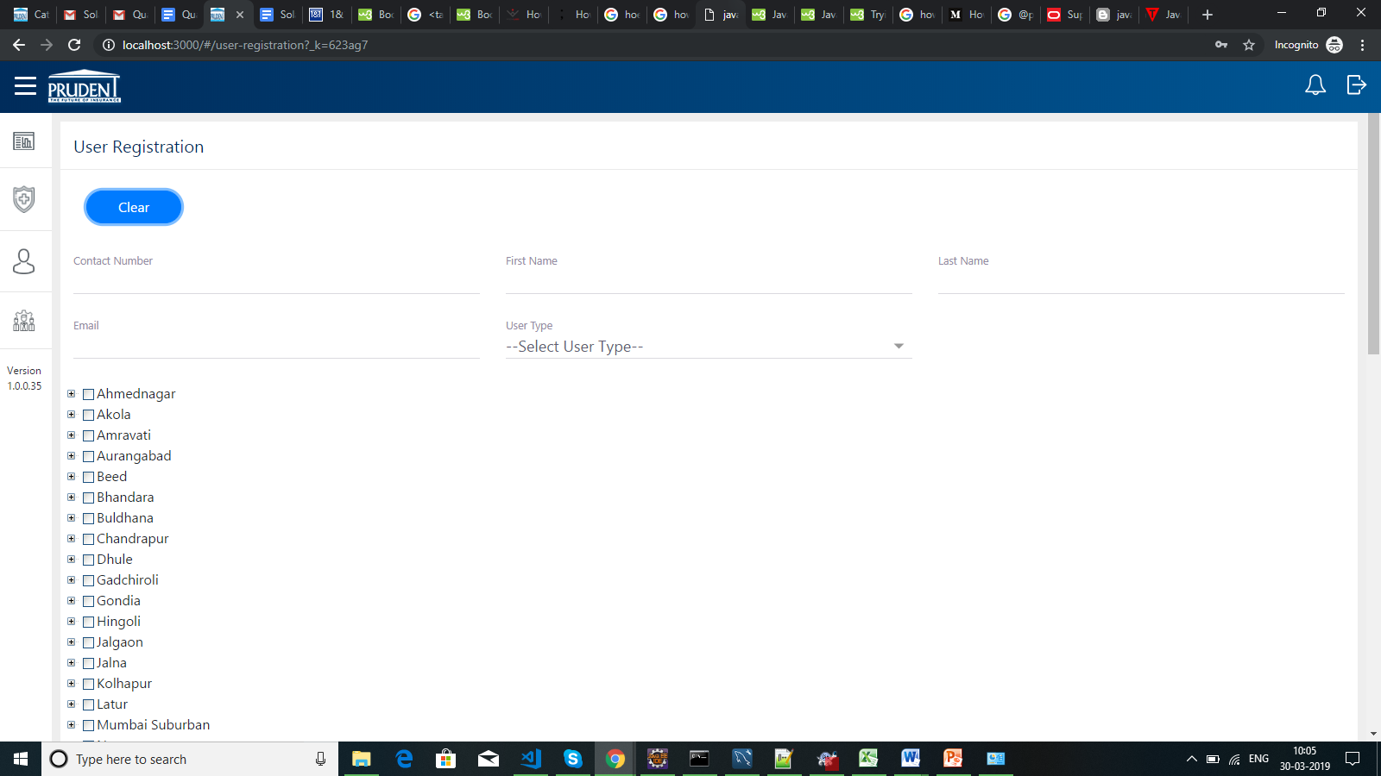

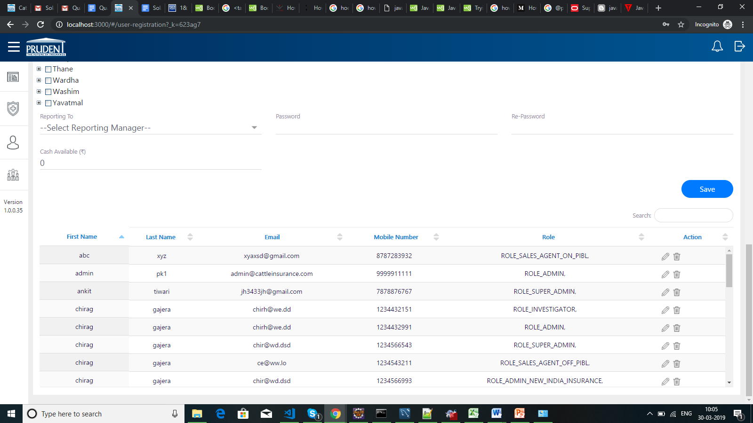

* User Registration with data

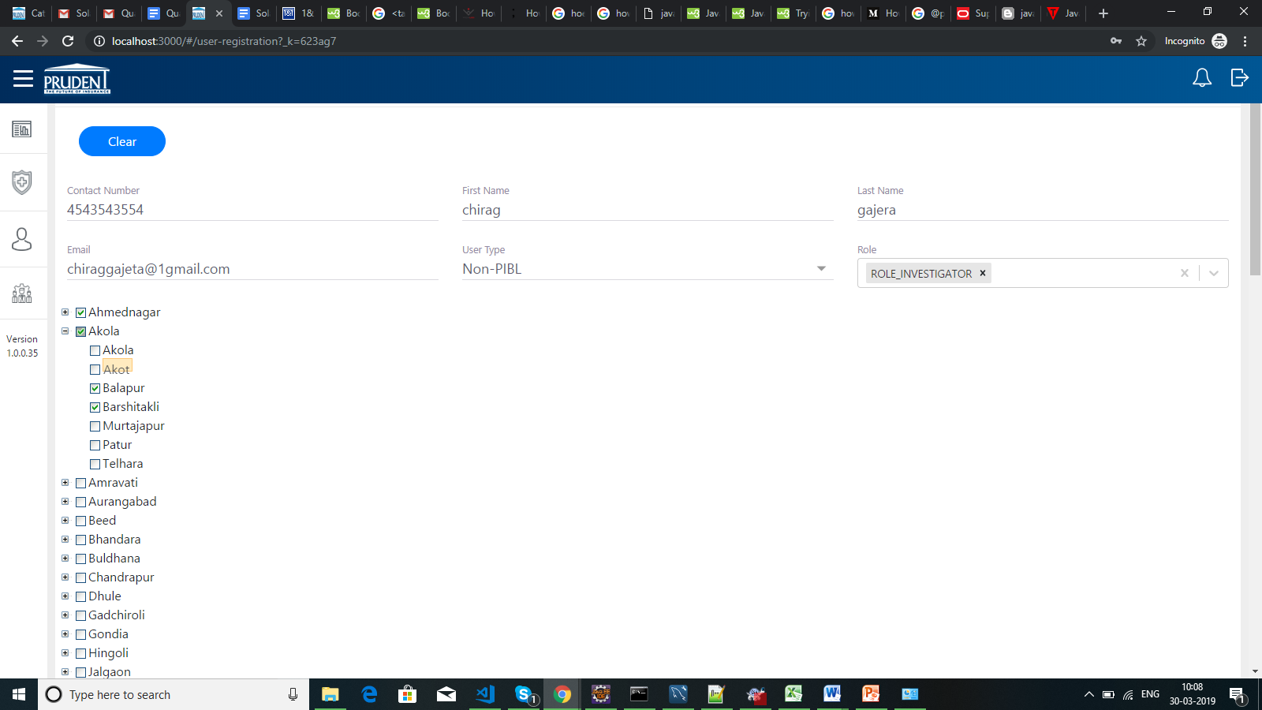

* User excel list upload

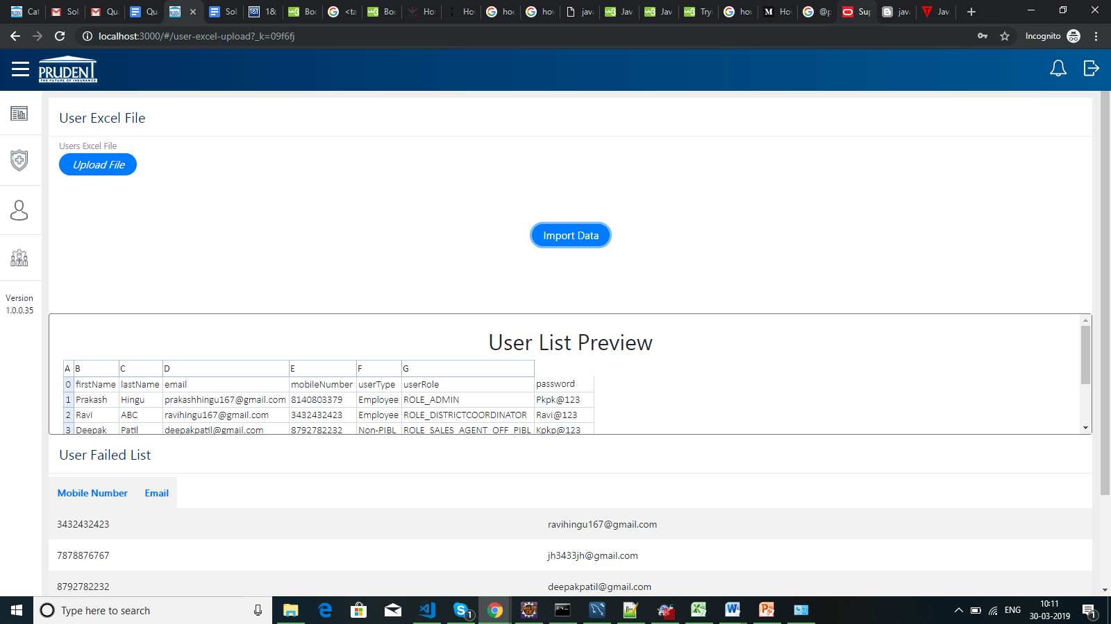

* Rate master

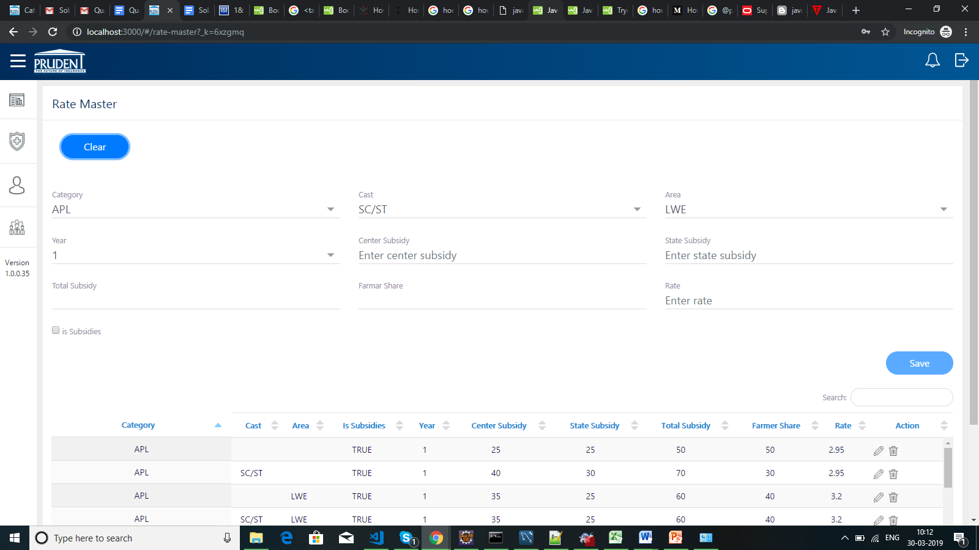

* Rate master edit mode



* Rate master validation

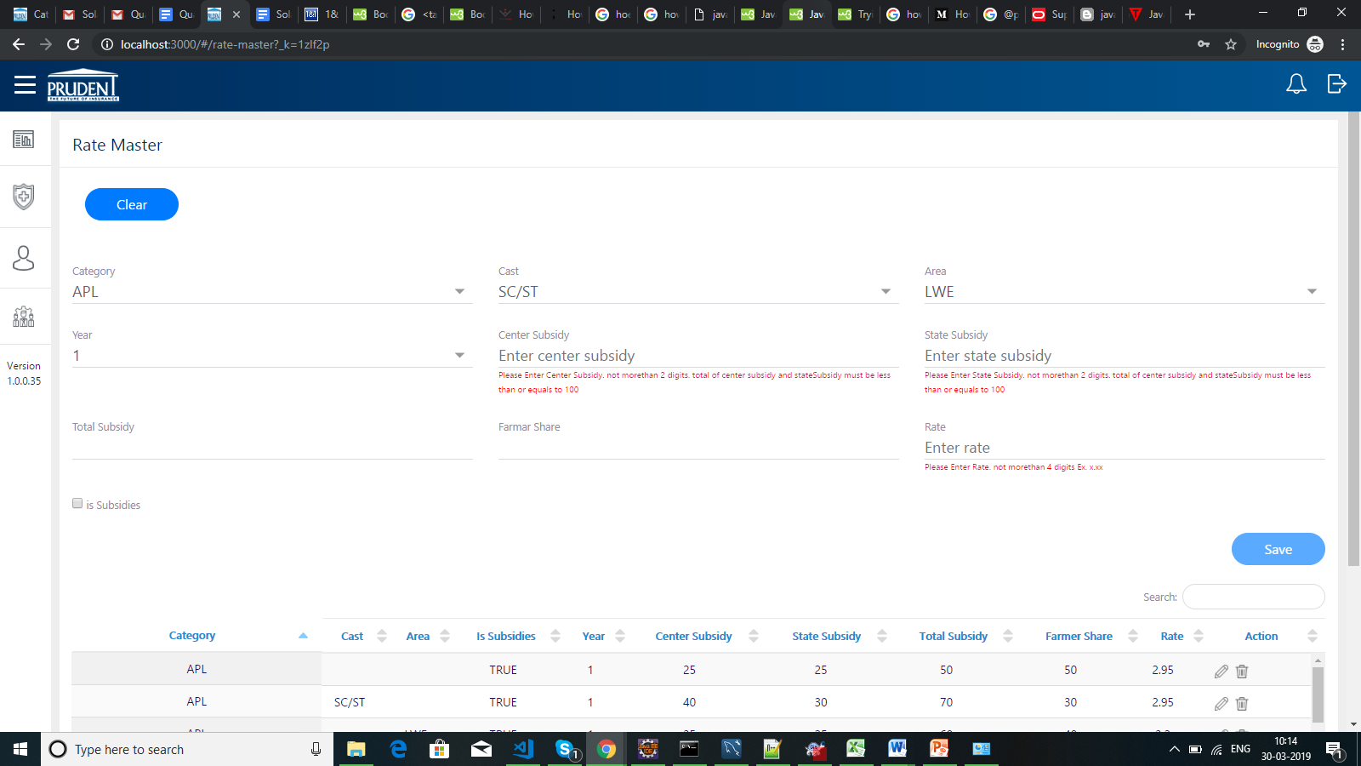

* SMTP configuration

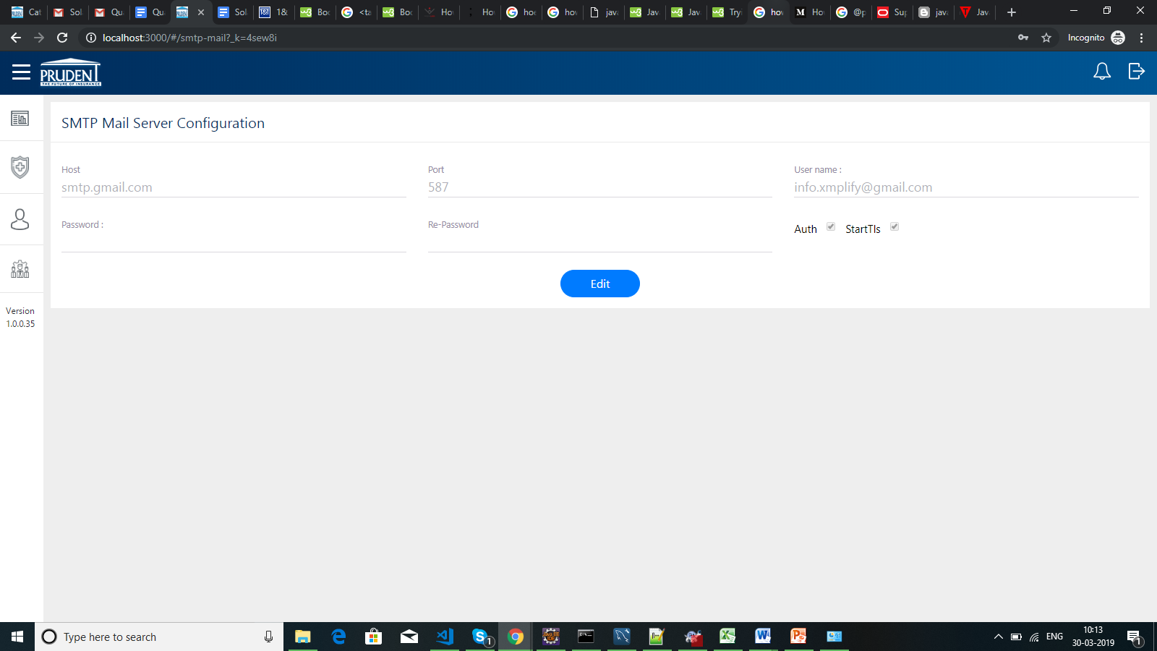

* SMTP configuration validation

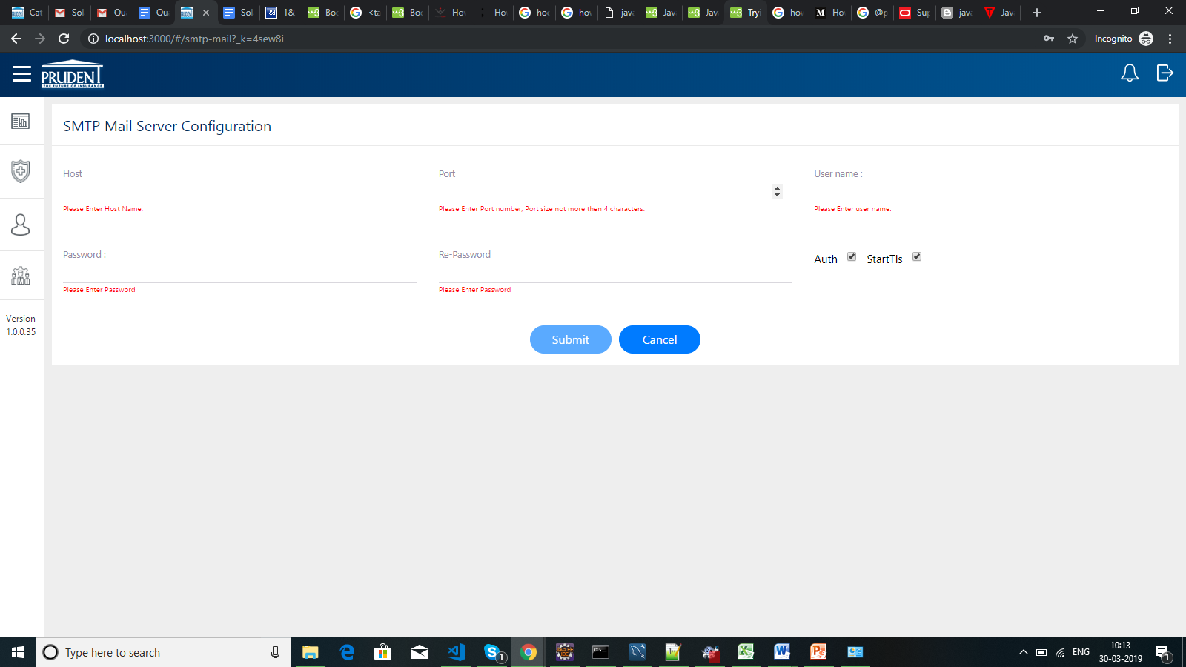

* Cattle category master

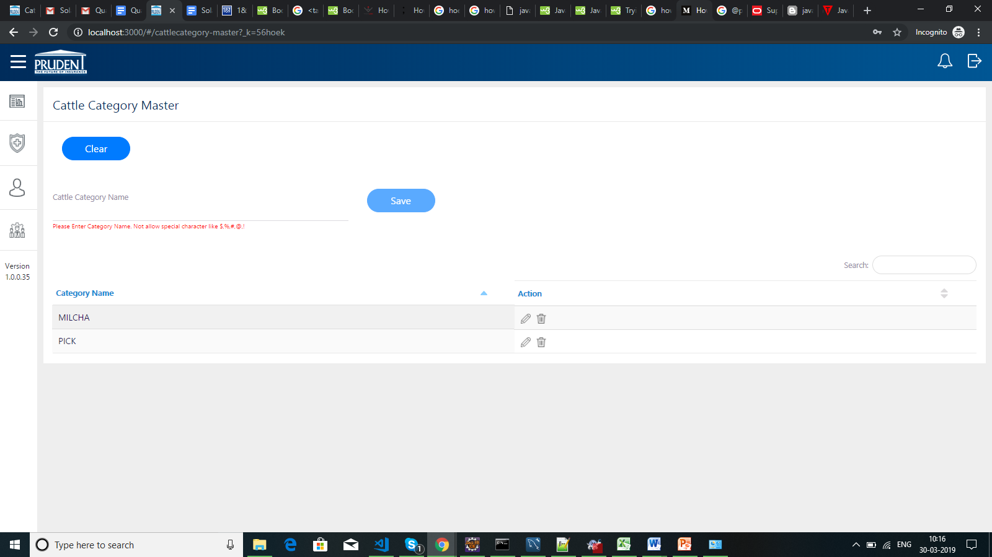

* Cattle category master edit mode

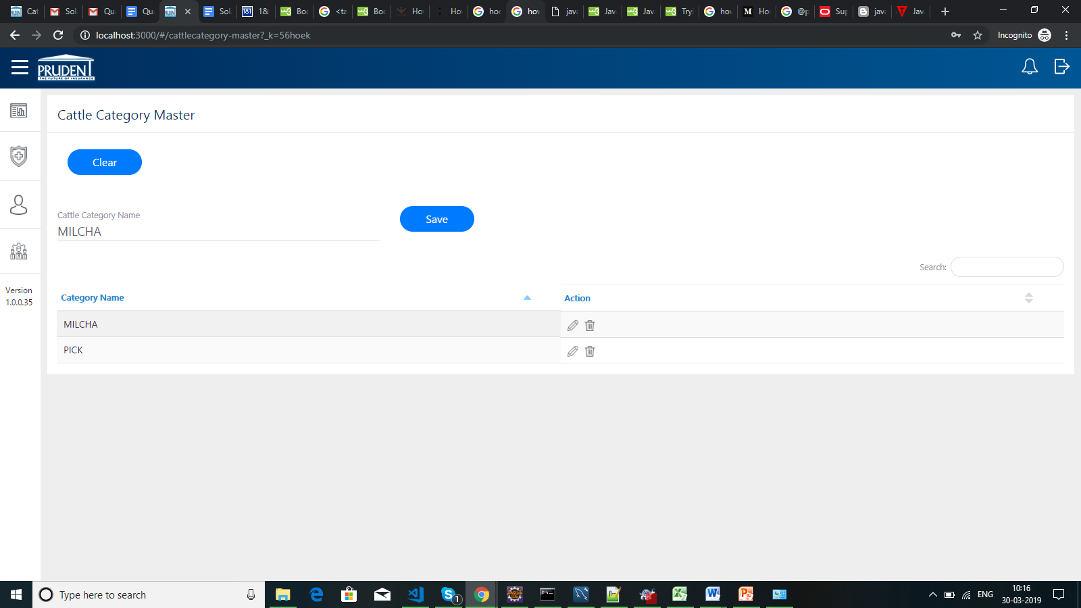

* Role based feature configuration

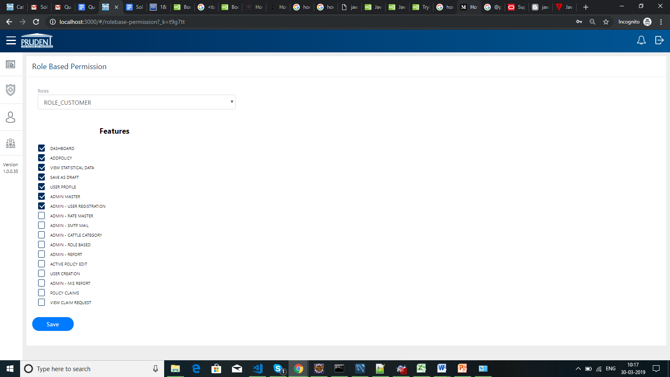

* Active policy reports

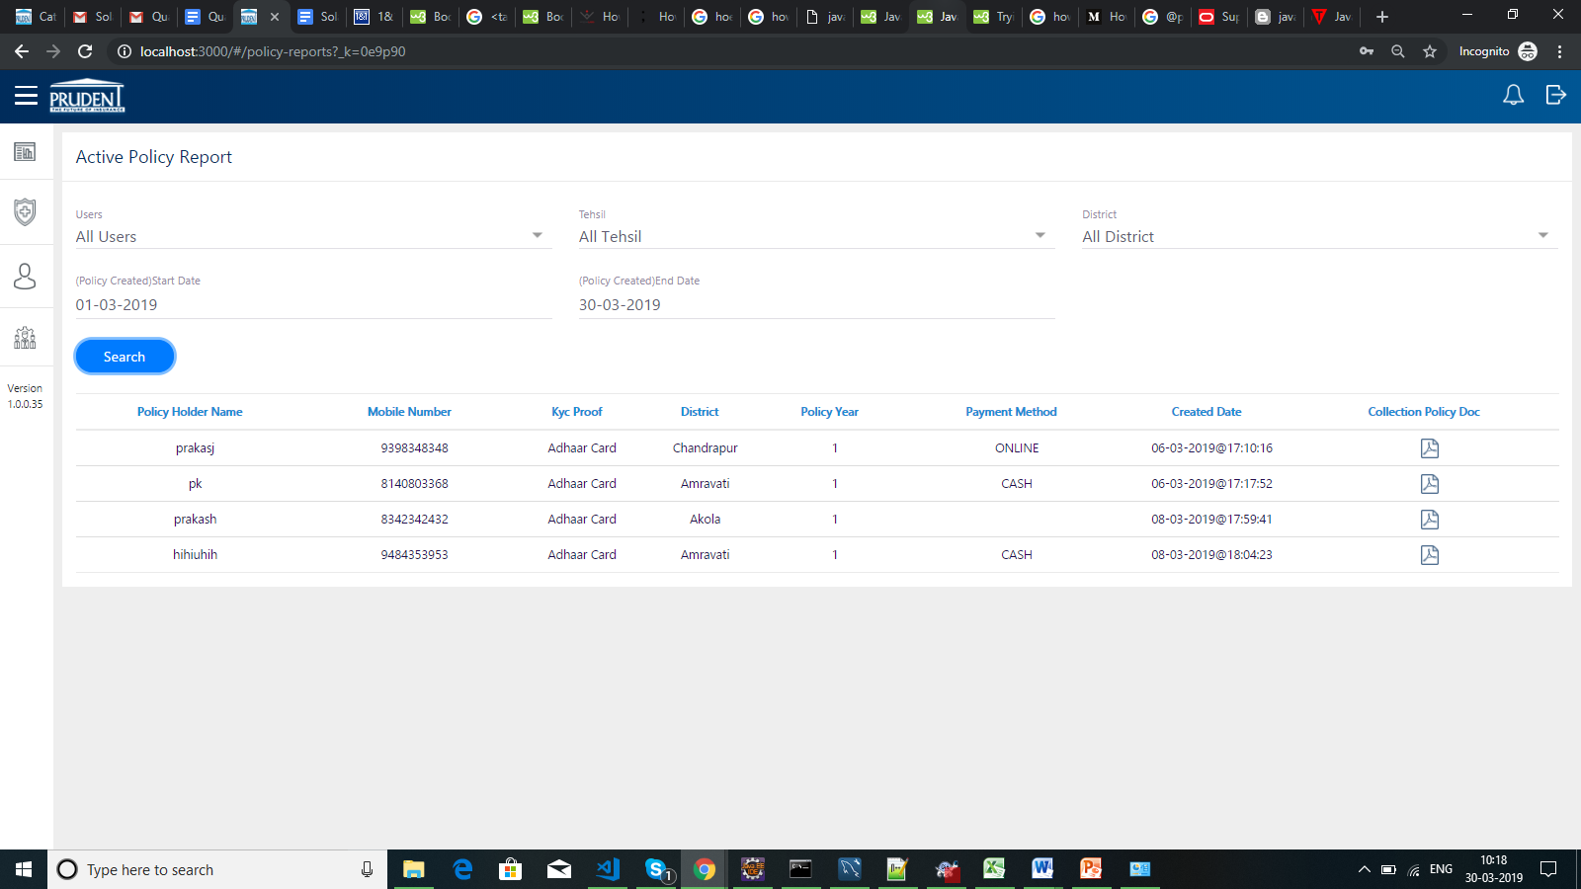

* Active policy view mode

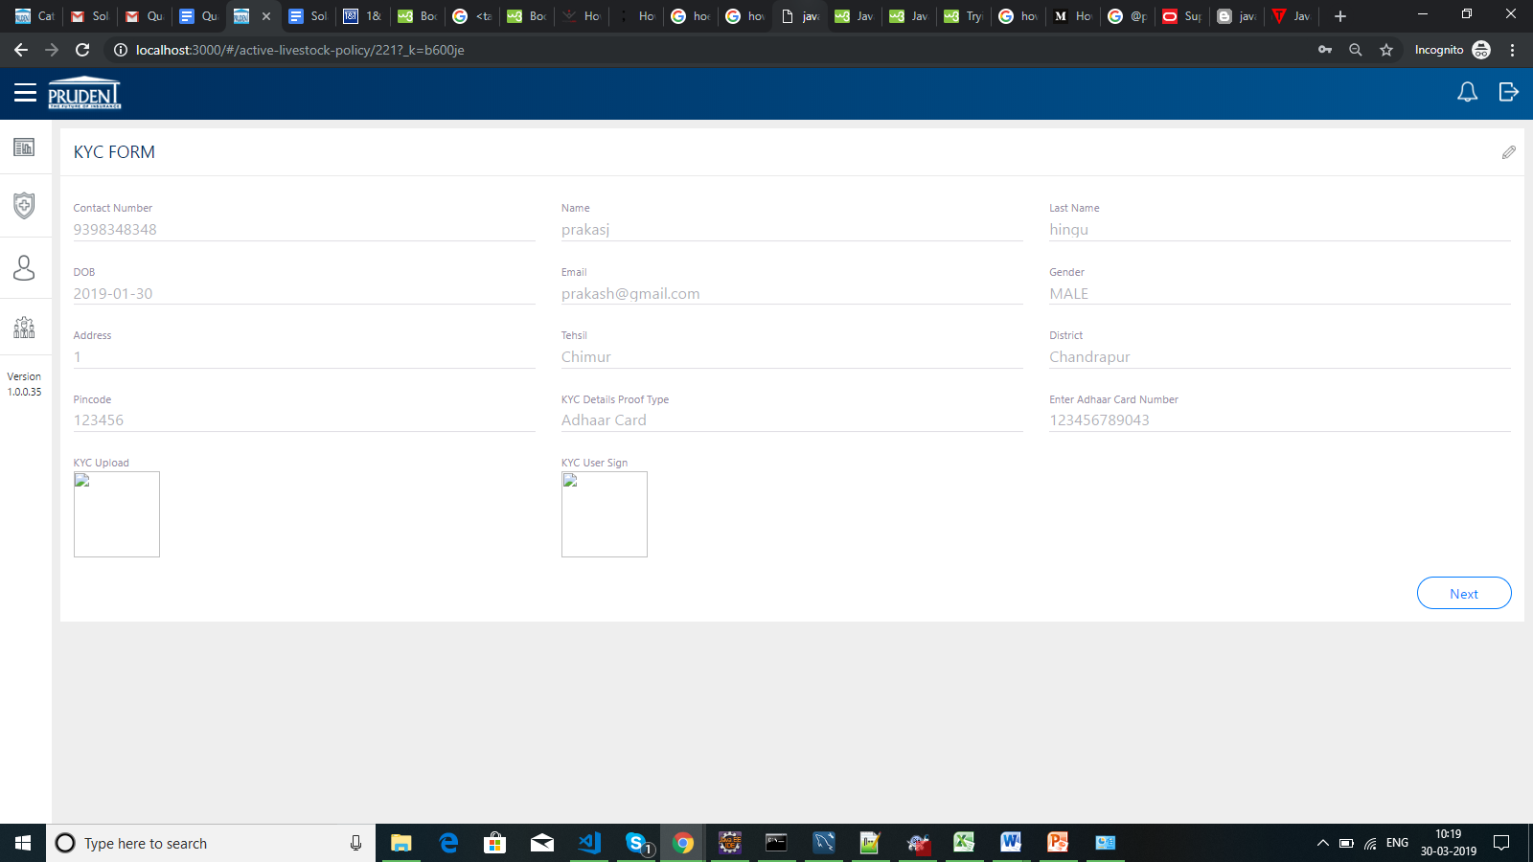

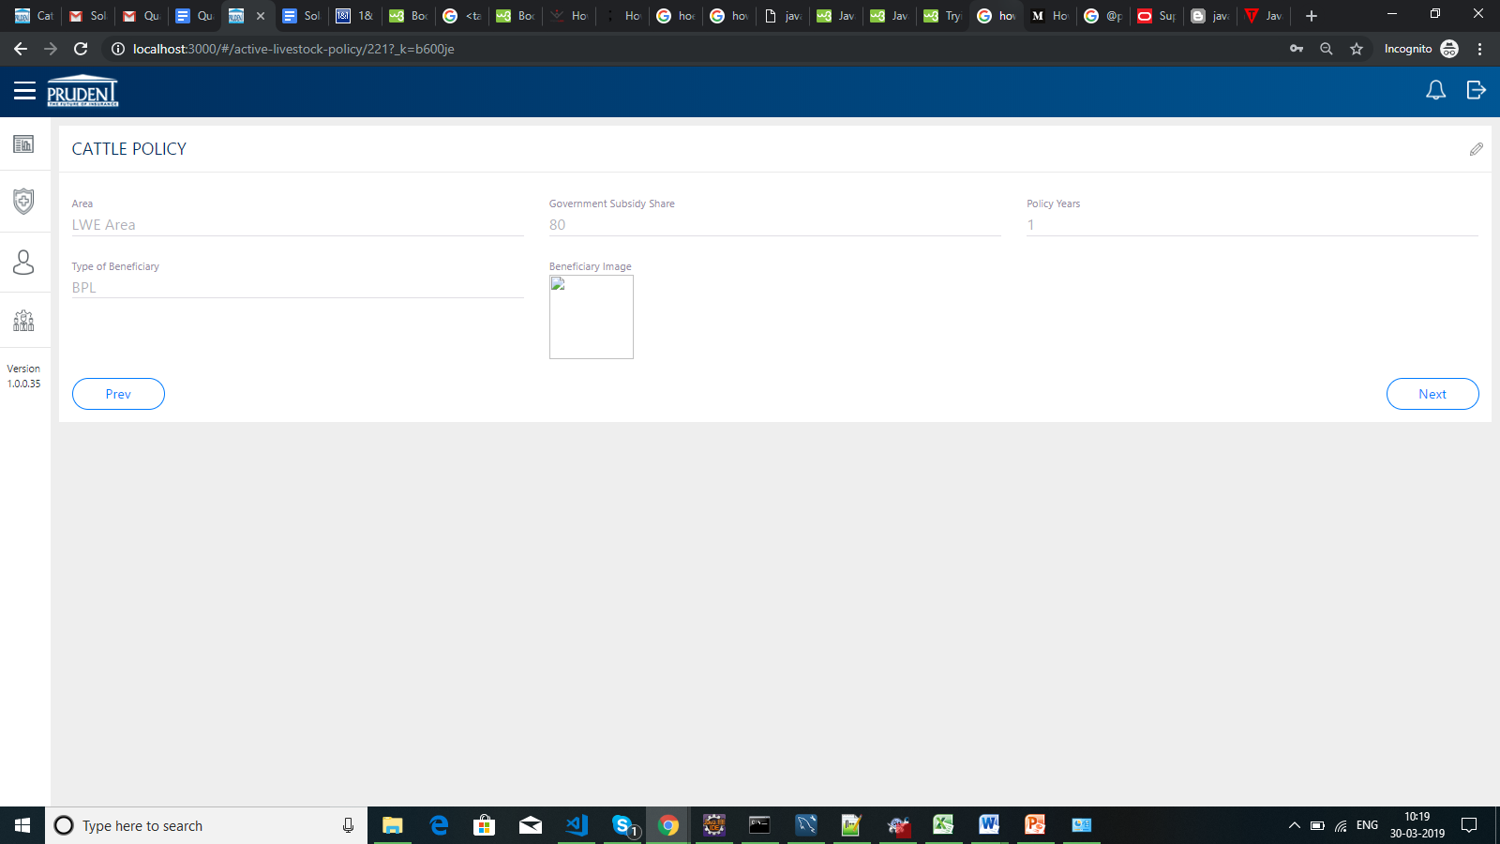

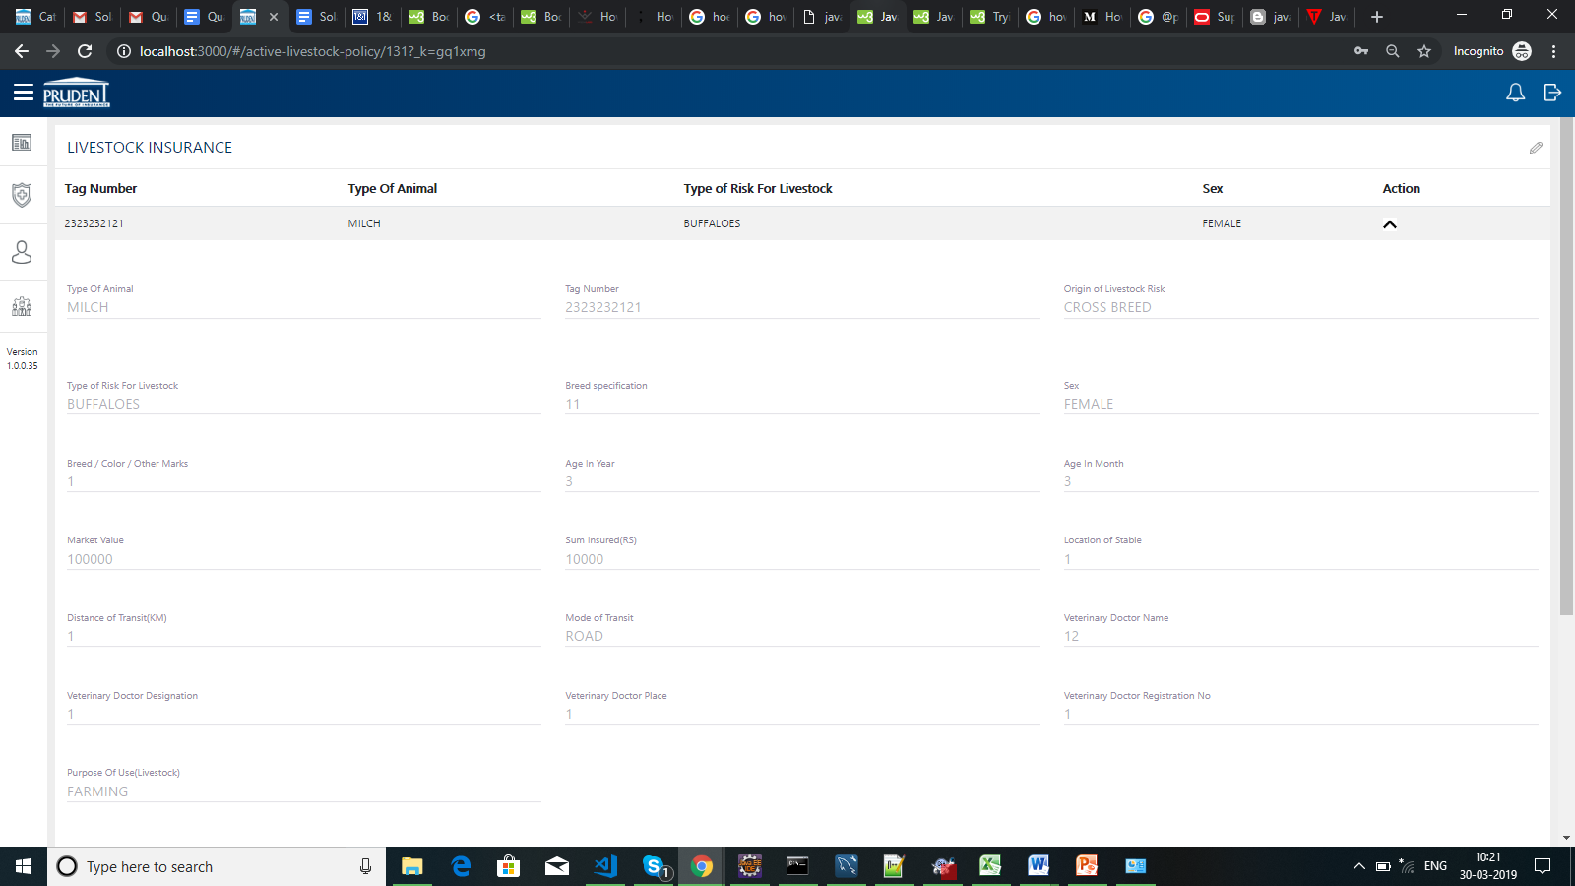

* MIS report generate excel.

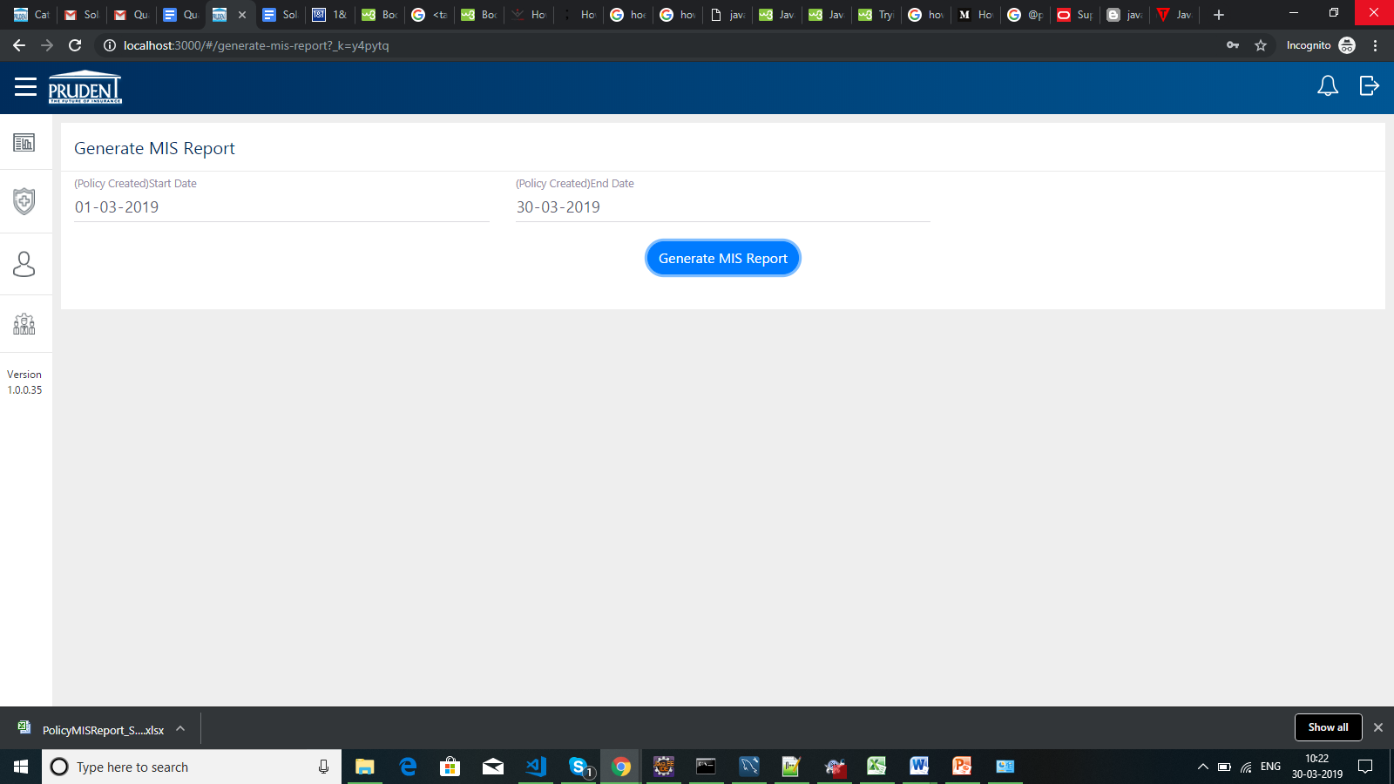

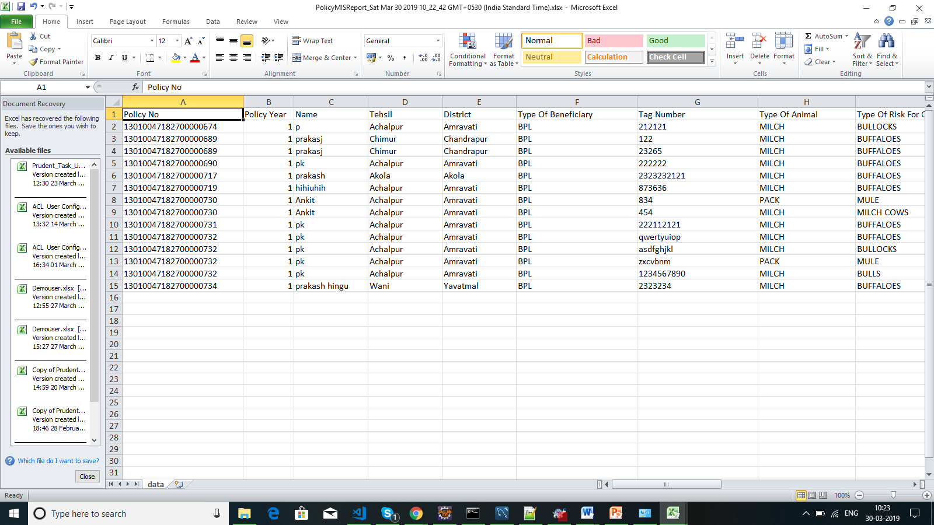

**REPORTS**

* MIS tool user wise sales.

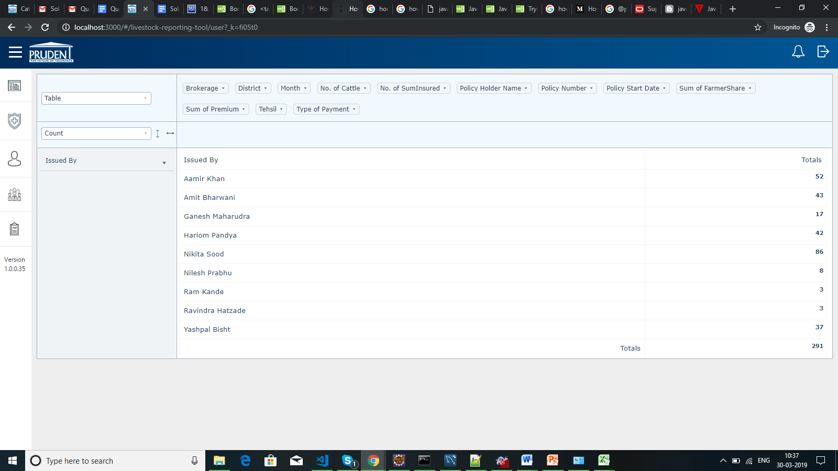

* MIS tool district wise sales

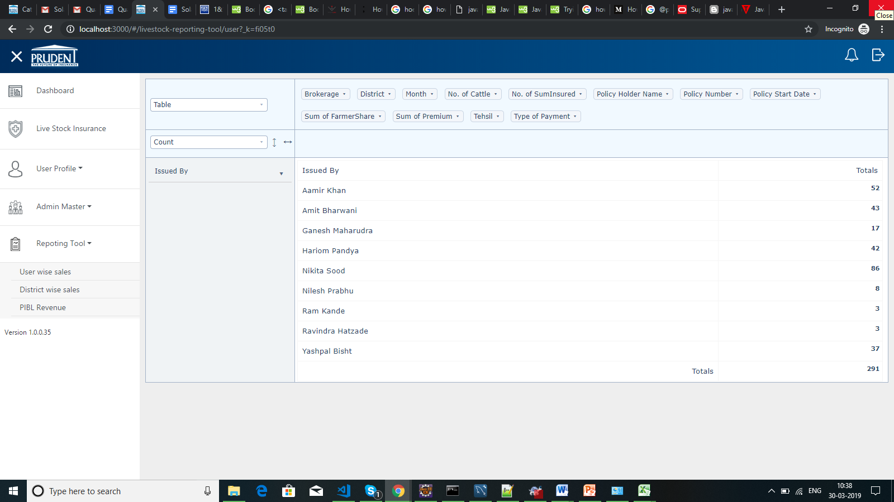

* MIS tool PIBL revenue

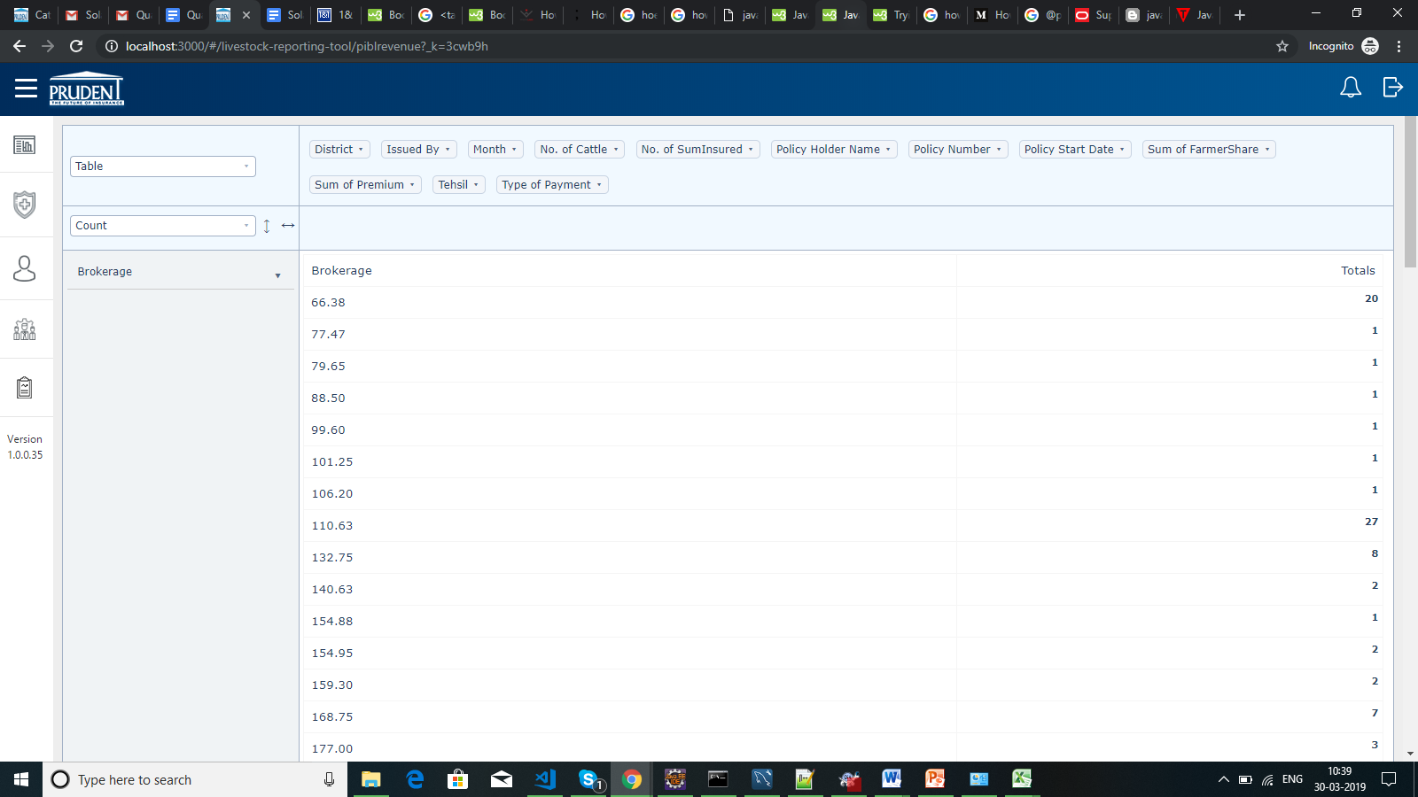

* MIS tool supports

